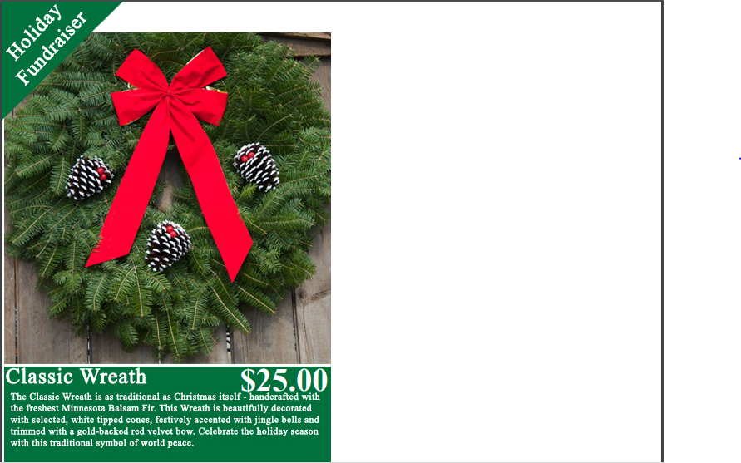

**United Presbyterian Church**

Name:______________________

Phone Number:______________

#____ of Wreaths

@ $25 each = Total $________

(Checks Payable to UPC)

**Submit your order by November 1st**

Delivery wil be the week of November 19th

*Thanks for Your Support!*