UNITED PRESBYTERIAN CHURCH
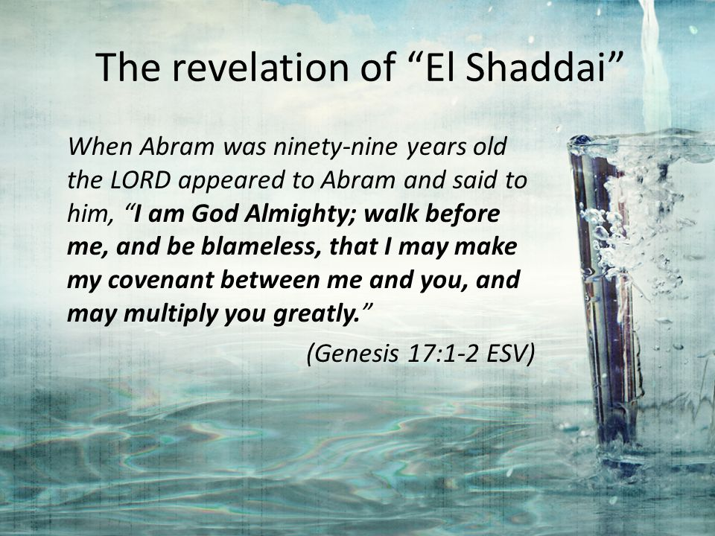
12 Yardville-Hamilton Square Road

Yardville, NJ 08620
(609) 585-5770
(609) 585-5674 fax
www.upcnj.org
February 25, 2018

WELCOME
Welcome! You have come to hear the Word of God, and you shall hear it read and preached. But we hope that by hearing it, you will also meet the Word of God, the Living Word, Jesus, our Master and Savior. And we pray that you will leave our church equipped to serve him more faithfully and effectively.

SERVICE FOR THE LORD’S DAY

February 25, 2018

PRELUDE “Have Mercy On Me, O God” J.S. Bach
ANNOUNCEMENTS

PRAYER HYMN “O God, Our Faithful God” 277
O God, our faithful God, O fountain ever flowing,
Without whom nothing is, all perfect gifts bestowing,
Grant us a faithful life, and give us, Lord, within,
Commitment free from strife, a soul unhurt by sin.

WE COME TO WORSHIP GOD

CALL TO WORSHIP
Leader: Lent calls us to journey, this and every day,
following Jesus wherever he leads us.
People: Lent calls us to journey:
to the place where God covenants with us,
to receive the new names we are given.
Leader: Lent calls us to worship together,
to tell future generations the good news.
People: Lent calls us to practice justice,
to bring God's hope to all people.
Leader: Lent calls us to faithful living,
to trust the One who gives us life.
People: Lent calls each of us to take up our cross,
to trust the One who bears it with us.
Leader: Lent calls us to journey with God.
People: Let us worship God, who walks with us,
this and every day.

*HYMN “Immortal, Invisible, God Only Wise” 263

CALL TO CONFESSION

PRAYER OF CONFESSION
God of Sarah and Abraham, in this holy place, we know how weak our discipleship is. We can spend hours at the computer, but only give you fleeting moments of our time. We can talk endlessly on our cell phones, but fall silent when it comes to sharing our fears, our worries, our hopes with you. We seek quick fixes for our problems, rather than seeking your vision and future for our lives.
God of Peter, Paul, and the psalmist, forgive us:
for our lack of trust;
for our faithless living;
for our closing our ears to the call of Jesus.
Forgive us, so we may lay aside all that keeps us from you, so we may take up the life you offer to us, through Jesus Christ, our Lord and Savior. Amen.

SILENT PRAYER

ASSURANCE OF PARDON

*GIVE GLORY TO GOD “Glory Be to the Father” 577
Glory be to the Father, and the Son, and the Holy Ghost;
As it was in the beginning, is now, and ever shall be,
World without end. Amen.
As it was in the beginning, is now, and ever shall be,
World without end. Amen.
Amen. Amen. Amen. Amen.
Amen. Amen. Amen.

PRAYER FOR ILLUMINATION

OLD TESTAMENT LESSON Genesis 17:1-7, 15-16
¹ When Abram was ninety-nine years old, the Lord appeared to Abram, and said to him, "I am God Almighty; walk before me, and be blameless. ² And I will make my covenant between me and you, and will make you exceedingly numerous." ³ Then Abram fell on his face; and God said to him, ⁴ "As for me, this is my covenant with you: You shall be the ancestor of a multitude of nations. ⁵ No longer shall your name be Abram, but your name shall be Abraham; for I have made you the ancestor of a multitude of nations. ⁶ I will make you exceedingly fruitful; and I will make nations of you, and kings shall come from you. ⁷ I will establish my covenant between me and you, and your offspring after you throughout their generations, for an everlasting covenant, to be God to you and to your offspring after you.
¹⁵ God said to Abraham, "As for Sarai your wife, you shall not call her Sarai, but Sarah shall be her name. ¹⁶ I will bless her, and moreover I will give you a son by her. I will bless her, and she shall give rise to nations; kings of peoples shall come from her."

A TIME WITH CHILDREN “A New Name” Rev. Jean B. Pinto

ANTHEM “Standing On the Promises” R. Kelso Carter

NEW TESTAMENT LESSON Romans 4:13-25
¹³ For the promise that he would inherit the world did not come to Abraham or to his descendants through the law but through the righteousness of faith. ¹⁴ If it is the adherents of the law who are to be the heirs, faith is null and the promise is void. ¹⁵ For the law brings wrath; but where there is no law, neither is there violation. ¹⁶ For this reason it depends on faith, in order that the promise may rest on grace and be guaranteed to all his descendants, not only to the adherents of the law but also to those who share the faith of Abraham (for he is the father of all of us, ¹⁷ as it is written, "I have made you the father of many nations")—in the presence of the God in whom he believed, who gives life to the dead and calls into existence the things that do not exist.
¹⁸ Hoping against hope, he believed that he would become "the father of many nations," according to what was said, "So numerous shall your descendants be." ¹⁹ He did not weaken in faith when he considered his own body, which was already as good as dead (for he was about a hundred years old), or when he considered the barrenness of Sarah's womb. ²⁰ No distrust made him waver concerning the promise of God, but he grew strong in his faith as he gave glory to God, ²¹ being fully convinced that God was able to do what he had promised.
²² Therefore his faith "was reckoned to him as righteousness." ²³ Now the words, "it was reckoned to him," were written not for his sake alone, ²⁴ but for ours also. It will be reckoned to us who believe in him who raised Jesus our Lord from the dead, ²⁵ who was handed over to death for our trespasses and was raised for our justification.

SERMON “23andAbraham” Rev. Jean B. Pinto

MOMENT FOR QUIET REFLECTION

*HYMN “The God of Abraham Praise” 488

Joys and concerns may be written on the pew cards and given to the ushers during this hymn. They will be shared during the prayers of the people, unless you mark them confidential.

WE RESPOND TO GOD’S WORD
*AFFIRMATION OF FAITH The Apostles’ Creed
I believe in God the Father Almighty, Maker of Heaven and earth. And in Jesus Christ his only Son our Lord; who was conceived by the Holy Ghost, born of the Virgin Mary, suffered under Pontius Pilate, was crucified, dead, and buried; he descended into hell; the third day he rose again from the dead; he ascended into heaven, and sitteth on the right hand of God the Father Almighty; from thence he shall come to judge the quick and the dead.
I believe in the Holy Ghost; the holy catholic church; the communion of saints; the forgiveness of sins; the resurrection of the body; and the life everlasting. Amen.

PRAYERS OF THE PEOPLE AND THE LORD’S PRAYER

CONGREGATIONAL RESPONSE
Hear our prayer, O Lord, Hear our prayer, O Lord
Incline Thine ear to us, And grant us Thy peace.

CALL FOR THE OFFERING

OFFERTORY “In Thee Lord Have I Put My Trust” F.W. Zachau

*WE GIVE PRAISE AND THANKS TO GOD (tune # 455)
Praise God from whom all blessings flow; Praise Him all creatures here below;
Alleluia, Alleluia. Praise Him above ye heav'nly host; Praise Father Son and Holy Ghost.
Alleluia! Alleluia! Alleluia! Alleluia! Alleluia!

*PRAYER TO DEDICATE OUR GIFTS
May these gifts represent our willingness to deny ourselves, so others might be blessed by your grace, your peace, as well as your hope, in every moment of their lives. In Jesus' name, we pray. Amen.

*HYMN “My Faith Looks Up to Thee” 383

*WE RECEIVE GOD’S BLESSING
POSTLUDE “The God of Abraham Praise” arr. H.Hopson
*Those who are able may stand.
Flowers: Given in Memory of Carol Metzger by Megan Gadsby, her granddaughter.

Greeters & Ushers: Sandy & Chrysti Neuman

Liturgist: Betty Reinert

UPCOMING EVENTS February 25th – March 4th
Sunday—February 25th 9:30 am E3 Worship Service
9:30 am Adult Sunday School
11:00 am Traditional Worship
6:00 pm Youth Group
Monday- February 26th 12:00 pm AA 8:00 pm NA
Tuesday- February 27th 12:00 pm AA
7:00 pm Women’s Book Club
Wednesday-February 28th 6:30 pm Webalos Scouts
7:00 pm AA Thursday—March 1st 7:30 pm Choir
8:00 pm AA
Friday------ March 2nd 8:00 pm AA
Saturday----March 3rd 9:00 am Garden State Prison Training Bertolet Lounge
Sunday— March 4th 9:30 am E3 Communion Worship Service
9:30 am Adult Sunday School
10:15 am Coffee Hour Hosted by Stewardship Finances
11:00 am Traditional Communion Worship
6:00 pm Youth Group
There are large print bulletins available. Please see an usher if you need this service.
Mission Spotlight – Our Mission Spotlight for February will be focused on Homefront. This organization helps transition the homeless to permanent housing as well as help provide emergency aid, food, clothing, and even furniture from a warehouse for those in need. All donations marked “Mission” will be forwarded to Homefront. Please consider donating generously to this worthy cause!
UPC’s Choir just presented a splendid Christmas Cantata and will beginning working on an Easter cantata by Robert Lau entitles “The Cross,” an artful and sensitive creation commemorating Christ's last week on earth from his triumphal Jerusalem entry and last meal with his disciples, to his agony on the cross and glorious resurrection. The familiar scriptural narration and simply designed hymn settings are woven into a seamless choral cantata, adding heightened meaning and understanding to Jesus' final journey. Rehearsal for this cantata began on Thursday, January 18, 2018 at 7:30 pm. There is a chair for any and all who love to make music! Come join! Dress Rehearsal will be Saturday, March 24th at 10:00am in the Sanctuary. Performance will be Sunday, Marth 25th during the 11:00 am Worship Service and there will be NO E3 service on March 25th. So, please come to learn, listen, and enjoy!

UPW - will have its meeting on Tuesday March 6, 2018 at 10:00 am in Fellowship Hall. A discussion of Chapter 3 entitled “Is God’s Will So Mysterious?” of the new book Discovering God's Will For Your Life by Sheila Walsh will take place during this meeting. There will also be a Birthday offering. All women of the church are cordially invited to join! After the meeting that is done at Noon, those women who would like to go for lunch are invited to go to a local restaurant

UPMen – will be meeting Saturday March 17th at the Golden Dawn Diner 9:00 am. The diner is located on Whitehorse-Mercerville Road, Hamilton Twp., NJ. Any questions, please contact Jim Dixon phone 609-298-3398 or email jdixonsr@comcast.net. Come on out and meet several leprechauns – if you can see them! It will be a most jolly breakfast, and enjoy the Christian fellowship with the men of UPC!!!

The Women's Book Club - will meet on Tuesday, the 27th of February in the Bertolet Lounge at 7:00 pm to discuss our classic selection HEIDI by Johanna Spyri which was published in 1880. Heidi is an inspiring story of a 5 year old orphan who is sent to live with her mean spirited grandfather in the Alps. We invite all women of the church and their friends who enjoy good books and fellowship to join us. Our March selection is WHAT WAS MINE by Helen Klein Ross.

Survivors - The Survivors Senior Group will meet at Homestead at Hamilton (retirement community), 2560 Kuser Road, Hamilton on March 14, 2018 at 10:30 a.m. for a tour of their facility. Following our tour we will enjoy lunch at Padrino's, 2452 Kuser Rd., Hamilton. If you plan to attend please make your reservation with Rita Peterson 259-7256 or email ritapete@optonline.net. All seniors of the church and their friends are welcome to join the Survivors for a very interesting tour and great lunch and fellowship.
UPC Youth Group Annual Pasta Dinner – will be held in Fellowship Hall at UPC on Saturday, March 10th 2018 from 5-7pm. Adult Tickets = $7.00 Children Tickets = $5.00. Please see Megan Gadsby, UPC Youth Leader OR inquire/see Mike Mraz, Church Office. Tickets will also be available prior to the Pasta Dinner!

PRAYER REQUESTS
Healing – for all those ill with cancer, undergoing surgery as well as treatment for cancer including Carol & Al D’Amico; John Demeter; Lenny; Dan Rose; Mathew Johnson; Pam Rose; Scott Rose; John Borak; Sue Fleming; Bud; Margaret Archibald’s Niece – Fiona suffering from rectal cancer; a family member of the LaCrosse family suffering from Chrohn’s Disease, her children’s needs as well as help with insurance coverage for treatment; Mike McHugh returned home; for those awaiting test results; Linda Ramos; for those in hospital, or, having surgery and in recuperation - including Matt Machin; Colin Thibodeau – having surgery on left arm @ CHOP; Crystal Purvis; Dave Carle – in rehab for hip; Nancy Dykas – knee replacement; Sarah Preston – hip replacement; Edith Owens; Jack & wife Pat Rich; Mike & wife Joyce Hatala; Karen Machin’s niece Donna; Pat Anthony; for those in need of improved health including Frank & Marilyn Kostar; Karen & Keith Ezzo; Gloria Gardecki and Family; Susan Anthony; Dot Brocaloni; Walt; Danny & Emily; Lin; Tony; Michelle’s cat – Serenity; Gloria Gadecki; Mary Jane – recuperating from a heart attack as well as strength for her family who are caring for her; friends of the LaCrosse family suffering from depression; those having personal problems like Carly Mauer; James Shedrick All of the victims & their families involved with the Florida school shootings.
Thanksgiving – for successful STEM cell treatment for Jenna Ciambelluca & continued healing.
Comfort for the Bereaved families and friends of Trudy Staab, Andre Bohy, & Glenna Ward.

Our Mission Statement
We are called by Jesus Christ and empowered by the Holy Spirit to celebrate and share the love of God with grace and joy.
Gracefully and joyfully we seek to share our gifts in the community through:
Open Doors
Diverse Worship
Innovative Education
Creative Mission
Dynamic Service

OUR CONGREGATION IN MISSION
Because of your stewardship commitment, the United Presbyterian Church is supporting the ministries of:
- The Presbyterian Church (U.S.A.) through Monmouth Presbytery; the Synod of the Northeast, and the General Assembly.
- Mobile Meals of Hamilton Township
- Princeton Theological Seminary Scholarship Fund
- Trenton Area Habitat for Humanity
- Trenton Area Rescue Mission
- Presbyterian Camp at Johnsonburg
- Trenton Area Soup Kitchen
- Pearson Memorial Food Bank
- Womanspace
- Homefront
- Trenton Area Campus Ministries

CHURCH STAFF
Ministers: All the members of the Congregation
Pastor: Rev. Jean B. Pinto (737-8011) jeanbpinto@gmail.com
Pastors Emeriti: Rev. Terry E. Fouse and Rev. John H. Milne
Organist: Marilyn Machmer
Choir Director: Michael Mraz
Church Secretary: Michael Mraz
Prayer Chain: Daytime: Carol Heberling (298-2594); Betty Reinert (585-5770)
Evening: Gail Fouse (585-3248); Joyce Vaughn (888-1187)

