UNITED PRESBYTERIAN CHURCH

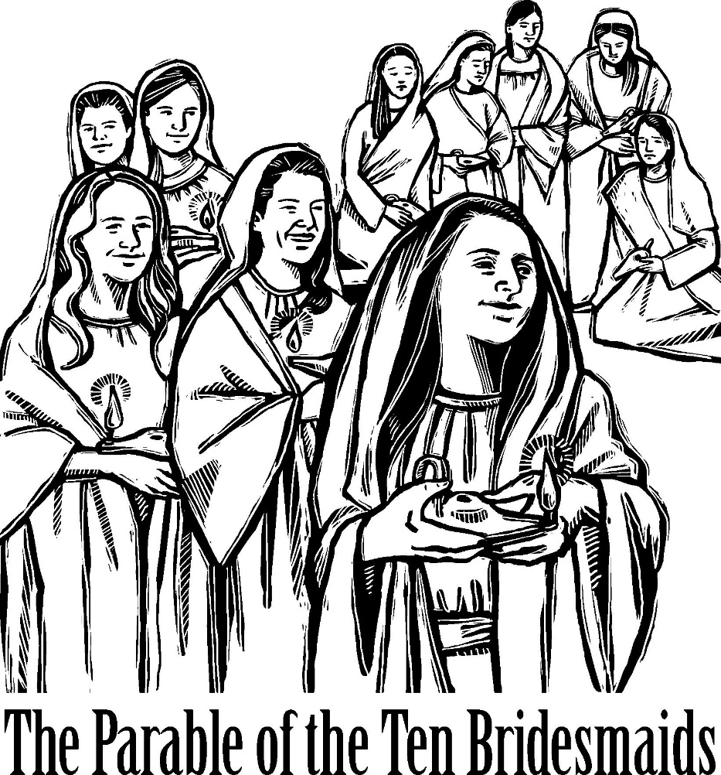

12 Yardville-Hamilton Square Road

Yardville, NJ 08620
(609) 585-5770
(609) 585-5674 fax
www.upcnj.org
November 12, 2017

WELCOME
Welcome! You have come to hear the Word of God, and you shall hear it read and preached. But we hope that by hearing it, you will also meet the Word of God, the Living Word, Jesus, our Master and Savior. And we pray that you will leave our church equipped to serve him more faithfully and effectively.
SERVICE FOR THE LORD’S DAY

November 12, 2017

PRELUDE “But the Lord Is Merciful of His Own” F. Mendelssohn
ANNOUNCEMENTS
PRAYER HYMN “O Splendor of God’s Glory Bright” 474
O splendor of God’s glory bright,
From light eternal bringing light;
Thou light of life, light’s living spring,
True day, all days illumining.
WE COME TO WORSHIP GOD
CALL TO WORSHIP
Leader: We gather to worship our God:
People: not only with those whose hearts overflow with joy,
but with those who long to offer their deepest sorrows.
Leader: We gather to follow Jesus:
People: not only with songs and prayers, but with lives of service and peace.
Leader: We gather to be filled with the Spirit's presence:
People: not only so we can wait patiently for the Bridegroom to come,
but so we can be with those who are impatient for justice and hope in their lives.

*HYMN “When Morning Gilds the Skies” 487

CALL TO CONFESSION
PRAYER OF CONFESSION
With insta-this and insta-that, we are an impatient people, God our help. We are so focused on our hand-held electronics, we do not notice the changing seasons. We are so rushed to get to our next activity, we do not see the victims of injustice by the side of the road. We are so determined to get right the date of your return, that we forget you are waiting for us to focus on what we can do with our days.
Forgive us, God our rescuer, and teach us patience. As we wait, may we continue to seek to do your will. As we do your will, may our eyes be opened to those around us. As our eyes are opened, may we see Jesus Christ, our Lord the Bridegroom, coming toward us with justice and righteousness as his companions. Amen.
ASSURANCE OF PARDON

*GIVE GLORY TO GOD “Glory Be to the Father” 577
Glory be to the Father, and the Son, and the Holy Ghost;
As it was in the beginning, is now, and ever shall be,
World without end. Amen.
As it was in the beginning, is now, and ever shall be,
World without end. Amen.
Amen. Amen. Amen. Amen.
Amen. Amen. Amen.
PRAYER FOR ILLUMINATION

OLD TESTAMENT LESSON Psalm 78:1-7
¹ Give ear, O my people, to my teaching;
incline your ears to the words of my mouth.
² I will open my mouth in a parable;
I will utter dark sayings from of old,
³ things that we have heard and known,
that our ancestors have told us.
⁴ We will not hide them from their children;
we will tell to the coming generation the glorious deeds of the Lord,
and his might, and the wonders that he has done.
⁵ He established a decree in Jacob, and appointed a law in Israel,
which he commanded our ancestors to teach to their children;
⁶ that the next generation might know them, the children yet unborn,
and rise up and tell them to their children,
⁷ so that they should set their hope in God,
and not forget the works of God, but keep his commandments;

CHILDREN’S SERMON “Be Prepared” Rev. Jean B. Pinto
ANTHEM “Guide My Feet” African-American Spiritual
NEW TESTAMENT LESSON Matthew 25:1-13
¹ "Then the kingdom of heaven will be like this. Ten bridesmaids took their lamps and went to meet the bridegroom. ² Five of them were foolish, and five were wise. ³ When the foolish took their lamps, they took no oil with them; ⁴ but the wise took flasks of oil with their lamps. ⁵ As the bridegroom was delayed, all of them became drowsy and slept.
⁶ But at midnight there was a shout, "Look! Here is the bridegroom! Come out to meet him.' ⁷ Then all those bridesmaids got up and trimmed their lamps. ⁸ The foolish said to the wise, "Give us some of your oil, for our lamps are going out.' ⁹ But the wise replied, "No! there will not be enough for you and for us; you had better go to the dealers and buy some for yourselves.' ¹⁰ And while they went to buy it, the bridegroom came, and those who were ready went with him into the wedding banquet; and the door was shut.
¹¹ Later the other bridesmaids came also, saying, "Lord, lord, open to us.' ¹² But he replied, "Truly I tell you, I do not know you.' ¹³ Keep awake therefore, for you know neither the day nor the hour.

SERMON “Murphy’s Law Inverted” Rev. Jean B. Pinto
MOMENT FOR QUIET REFLECTION

*HYMN “O Word of God Incarnate” 327
Joys and concerns may be written on the pew cards and given to the ushers during this hymn. They will be shared during the prayers of the people, unless you mark them confidential.

WE RESPOND TO GOD’S WORD

* AFFIRMATION OF FAITH “The Apostles’ Creed” I believe in God the Father Almighty, Maker of Heaven and earth. And in Jesus Christ his only Son our Lord; who was conceived by the Holy Ghost, born of the Virgin Mary, suffered under Pontius Pilate, was crucified, dead, and buried; he descended into hell; the third day he rose again from the dead; he ascended into heaven, and sitteth on the right hand of God the Father Almighty; from thence he shall come to judge the quick and the dead.
I believe in the Holy Ghost; the holy catholic church; the communion of saints; the forgiveness of sins; the resurrection of the body; and the life everlasting. Amen.

PRAYERS OF THE PEOPLE AND THE LORD’S PRAYER

CONGREGATIONAL RESPONSE
Hear our prayer, O Lord, Hear our prayer, O Lord
Incline Thine ear to us, And grant us Thy peace.

CALL FOR THE OFFERING

OFFERTORY In Heavenly Love Abiding” arr. W. Held

*WE GIVE PRAISE AND THANKS TO GOD (tune # 455)
Praise God from whom all blessings flow; Praise Him all creatures here below;
Alleluia, Alleluia. Praise Him above ye heav'nly host; Praise Father Son and Holy Ghost.
Alleluia! Alleluia! Alleluia! Alleluia! Alleluia!

*PRAYER TO DEDICATE OUR GIFTS
It seems like just a drop, the gifts we offer to you from our abundance. But our drop added to hers, then to his, then to theirs soon turns into a river of hope, a flood of peace, a torrent of grace rushing into and through our world. May it be so, Just God, may it be so. Amen

*HYMN “God of Grace and God of Glory” 420
*WE RECEIVE GOD’S BLESSING POSTLUDE “Praise Him, Praise Him” arr.W. Held

Liturgist: Jim Dixon
Flowers: Given In Memory of Lew Thorn by the Giordano & Miccio Families.
Greeters & Ushers: Dot Schroeder & Lydia Patterson

UPCOMING EVENTS November 12th – November 19th
Sunday---November 12th 9:30 am E3 Worship Service
9:30 am Adult Sunday School
11:00 am Traditional Worship
12:00 pm Nominating Committee Meeting
6:00 pm Youth Group
Monday- November 13th 12:00 pm AA
7:00 pm Outreach Meeting
8:00 pm NA
Tuesday- November 14th 12:00 pm AA
Wednesday-November 15th 6:30 pm Webelos Cub Scouts
7:00 pm AA
Thursday-November 16th 7:00 pm Girl Scouts
7:30 pm Choir
8:00 pm AA
Friday---- November 17th 4:15 pm Girl Scouts
8:00 pm AA
Saturday—November 18th 9:00 am UPMen’s Breakfast Golden Dawn Diner
Sunday— November 19th 9:30 am E3 Worship
11:00 am Traditional Worship
6:00 – 8:00 pm Youth Group
7:00 pm Scouts – Philamont Group
There are large print bulletins available. Please see an usher if you need this service.

SAVE the DATE – November 22, 2017 – 7:00 pm – St. Mark’s Hamilton, NJ Eccumenical Thanksgiving Service.

November Dual Mission Project – The first project will be donating offering funds to the PDA (Presbyterian Disaster Assistance) The PDA is helping those living in the Northern Lesser Antilles, Puerto Rico, the Virgin Islands, and Cuba rebuild from the September Category 5 hurricane strike. The second project is through offering funding donating to the Pearson Memorial Food Pantry that serves those in need in our own locality of Hamilton. Please give generously to Mission during November knowing every penny will go to help our neighbors in need! Thank you for your compassion and willingness to give.

Order your gift cards soon! The order will go in November 14th. Please have your orders in the church office by November 13th. Next and final order is December 12th. Forms are on the table in the Narthex.

The Women's Book Club will meet on Tuesday, November 28th at 7:00 pm in the Bertolet Lounge. We will be discussing SMALL, GREAT THINGS by Jodi Picoult who tackles the race issue in this new novel. Ruth, an African American experienced nurse, is confronted by Turk, a white supremacist in the hospital delivery room. All women of the church and their friends who enjoy good books, delicious desserts, and wonderful fellowship are encouraged to join us. No meeting in December. January’s selection - THE DRESSMAKER By Kate Alcott

The United Presbyterian Women - SAVE THE DATE! UPW Luncheon December 3rd @ 12:30 pm Amari’s 3400 S. Broad Street Hamilton, NJ. Please read and acknowledge form insert.

CHOIR – Choir has begun rehearsing the Christmas Cantata “Christ Was Born for This” by Dennis & Nancy Allen. This contemporary cantata is a collection of traditional carols done in contemporary style as well as very singable songs stating why Jesus Christ was born. He came to break the curses under which we lived, and to turn them into blessings for the believer. Rehearsals are on each Thursday beginning August 31st straight through each Thursdays of September, October, and November. Dress rehearsal will be Saturday, December 9th @ 10:00 am, and the performance will be Sunday, December 10th during the 1L00 am traditional service.There will be NO E3 service @ 9:30 am on December 10th. Please come as a listener or as a performer. We learn, sing, and have fun!

Survivors Community Project – A collection box is in the back of the Sanctuary for donation to T.A.S.K. of NEW mittens/gloves, Scarves, caps/hats, and sweatshirts with hoods. These items are for winter warmth for those in need! Please be generous. The deadline for donating is Sunday December 3, 2017.

UPMen’s Breakfast - will be meeting November 18th ^{t}at the Golden Dawn Diner 9 am 2090 Whitehorse-
Mercerville Road where breakfast fellowship is always the best! BTW A new well known member may shake your hand – Mr. M. (Muffin) Man! He’s a bit shy, and if you don’t shake his hand this month – well – there’s always the month of December!

Pie & Wreath Orders are due TODAY! Order forms are on the table in the Narthex! Megan Gadsby gets the pie orders and Rosemarie Wales gets the Wreath orders.

Our Mission Statement
We are called by Jesus Christ and empowered by the Holy Spirit to celebrate and share the love of God with grace and joy.
Gracefully and joyfully we seek to share our gifts in the community through:
Open Doors
Diverse Worship
Innovative Education
Creative Mission
Dynamic Service

PRAYER REQUESTS
Healing for: Maria, Angela Accardi, Bud 2nd cancer surgery; Angelica – breast cancer, Peggy, Bill Kleppe (co-worker friend of Holly Cardinale) – chemo for kidney cancer; Donna Ramsey (Holly Cardinale’s cousin) – diagnosed with Multiple Myeloma; Marvin, Ryan, Reilly Paige, Wayne, John Borak – bowel blockage and cancer; Pam and Dan Rose; Ron, Bill, Kyle, Lenny, Pat, Jodi Mannix – undergoing chemotherapy; Cathy, Sally, Carolyn McPhee, Stanley – tests for lung cancer; Connie Davis and Andrea Pinto all undergoing treatment for cancer; Leo Clement; Dot Bracaloni; Susan Anthony; Al & Carol D’Amico; Scott Rose; Bob D’Angelo; Dianna – successful surgery prayers on 11/8; Billy Kocis – throat (tonsil) cancer; Amanda Lowe – kidney complications; Post-Op surgery healing – Bob Young, Michelle C.; Chelsea Mitchel – healing of illness while at school; Stefan Revesz; Jim – concern & healing fromn severe back pain; Marissa G. – who is critically ill; Matthew Johnson – support and healing from leukemia; A member of the LaCrosse family suffering from cancer as well as another (overwhelmed) family member strength to cope with caregiving; Ali – healing brain surgery for a tumor and ensuing treatment; Julianna – life threatening reaction to anesthesia; Tony Nami – had emergency surgery and in need for healing without complications; Steve – ankle reconstruction surgery this week; Kieran Pillion – healing from heart by-pass surgery; Helen Fisher – suffering from Alzheimers as well as prayers of support for the extended Fisher family Michelle – back surgery; Healing for the family of Mrs. Henry; Frank Kostar-heart issues; Marilyn Kostar – health issues and coping with Frank; Girja Singh – strength for future operation; the Briggs Family – oldest daughter having 1 kidney transplant (kidney coming from husband, John) and mother Terri will be caring for both Lisa & John; Healing for Mike McHugh – hospitalized with an infection & Nancy McHugh (family) – strength for dealing with illness and an aging parent; Mrs. Walter – recovering from broken hip and broken rib; Debbie Furchak, their daughter who is in need of peace and strength while supervising the care for both her parents who are both in a living/memory care unit; Healing, strength, and support for Ed in ongoing heart rehab and wife Barbara; Debbie – surgery Friday 11/3/17; Continued prayer for the following – Tony, John; Emily & Danny Matt; Patrick. Pray for Lili, Landia, and Harrison French for reconciliation; Mathew Johnson (Tom Zeyack’s grandson) – treatment for leukemia.
Thanksgiving – and blessings for all children & grandchildren as well as keep them safe, blessings; successful shoulder surgery for Eileen Abatto; Colton Thibodeau – medication is successfully controlling his seizures.
Comfort – for the Bereaved families of Eugene Puzio & Donna Lee Kuebler.
Concern – Control of seizures for James Bade and wisdom for the doctors to successfully treat his seizures; ALL families involved with (Hurricanes Harvey, Irma, & Maria) storm flooding in Puerto Rico, Texas, Florida, India, and Southeast Asia as well as fires in the western United States ,and those devastated by an earthquakes in Mexico; Travis dealing with spiritual battle while in prison; Co-worker of Nancy who is in distress; All Caregivers; Prayer for Debbie having a new job interview this week; Prayer of support needed to a local homeless person and a prayer for God to watch over James Sheedrick; Justin Hanewald (Marine’s) being deployed to guard the border between North/South Korea.

OUR CONGREGATION IN MISSION
Because of your stewardship commitment, the United Presbyterian Church is supporting the ministries of:
- The Presbyterian Church (U.S.A.) through Monmouth Presbytery; the Synod of the Northeast, and the General Assembly.
- Mobile Meals of Hamilton Township
- Princeton Theological Seminary Scholarship Fund
- Trenton Area Habitat for Humanity
- Trenton Area Rescue Mission
- Presbyterian Camp at Johnsonburg
- Trenton Area Soup Kitchen
- Pearson Memorial Food Bank
- Womanspace
- Homefront

CHURCH STAFF
Ministers: All the members of the Congregation
Pastor: Rev. Jean B. Pinto (737-8011) jeanbpinto@gmail.com
Pastors Emeriti: Rev. Terry E. Fouse and Rev. John H. Milne
Organist: Marilyn Machmer
Choir Director: Michael Mraz
Church Secretary: Michael Mraz
Prayer Chain: Daytime: Carol Heberling (298-2594); Betty Reinert (585-5770)
Evening: Gail Fouse (585-3248); Joyce Vaughn (888-1187)

