UNITED PRESBYTERIAN CHURCH
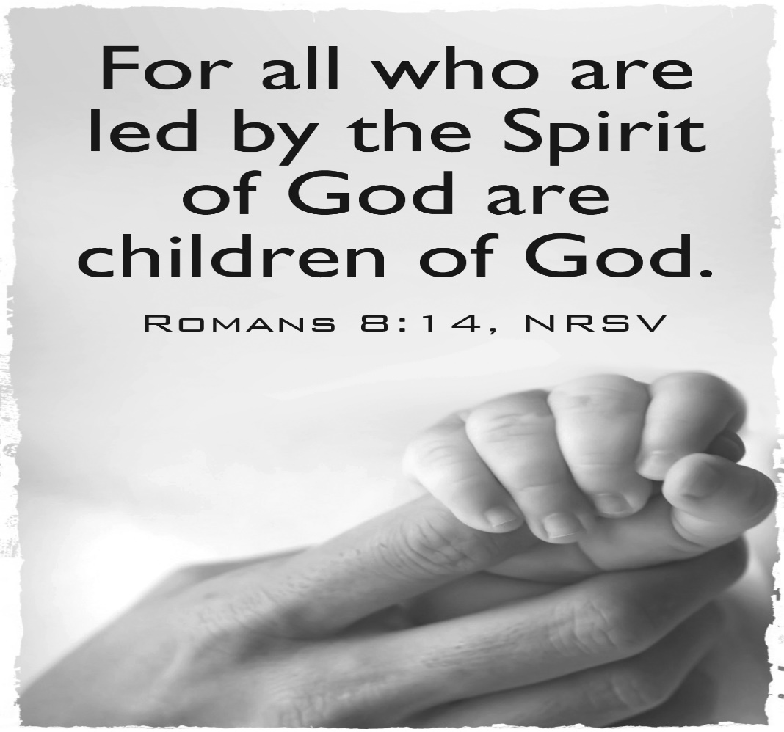

12 Yardville-Hamilton Square Road
Yardville, NJ 08620
Phone: (609) 585-5770
(609) 585-5674 fax
www.upcnj.org.
May 27, 2018

WELCOME
Welcome! You have come to hear the Word of God, and you shall hear it read and preached. But we hope that by hearing it, you will also meet the Word of God, the Living Word, Jesus, our Master and Savior. And we pray that you will leave our church equipped to serve him more faithfully and effectively.

SERVICE FOR THE LORD’S DAY
Trinity Sunday

May 27 2018

PRELUDE “Cantilena” J. Rheinberger
ANNOUNCEMENTS

PRAYER HYMN “Holy God, We Praise Your Name 460
Holy God, we praise Your name;
Lord of all, we bow before You;
All on earth Your scepter claim,
All in heaven above adore you.
Infinite Your vast domain,
Everlasting is Your reign.

WE COME TO WORSHIP GOD

CALL TO WORSHIP
Leader: God, who flung the stars into the night sky,
rejoices over all creation, especially us!
People: Come to us, Laughing God, and gladden
our hearts with your goodness and grace.
Leader: Christ, the Word of joy and life,
fills all creation with hope, especially us!
People: Come to us, Brother and Savior, and reclaim
our hearts as your own.
Leader: The Spirit, who breathes life into emptiness,
gives all creation the gift of peace, especially us!
People: Come to us, Spirit of Gentleness, and refresh us
with the dew of delight.

*HYMN “Holy, Holy, Holy! Lord God Almighty!” 138

CALL TO CONFESSION

PRAYER OF CONFESSION
In the mystery of creation, Imaginative God, you shaped beauty and goodness, yet we damage it by our selfishness and anger. In the mystery of life, Child of Hope, you became one of us, yet all too often we turn our back on you. In the mystery of peace, Breath of Life, you would calm our natures, yet we cling tenaciously to our bitterness and hurt.
In the mystery of grace, Holy God, you forgive us our sins, that we might embrace others. In the mystery of mercy, you touch our lips, that we might speak gently to others. In the mystery of hope, you claim us as family, sisters and brothers of the One who brought new life for all, Jesus Christ, our Lord and Savior. Amen.

ASSURANCE OF PARDON

*GIVE GLORY TO GOD “Glory Be to the Father” 577
Glory be to the Father, and the Son, and the Holy Ghost;
As it was in the beginning, is now, and ever shall be,
World without end. Amen.
As it was in the beginning, is now, and ever shall be,
World without end. Amen.
Amen. Amen. Amen. Amen.
Amen. Amen. Amen.
PRAYER FOR ILLUMINATION

OLD TESTAMENT LESSON Psalm 29:1-4, 10b-11
¹ Ascribe to the Lord, O heavenly beings, ascribe to the Lord glory and strength.
² Ascribe to the Lord the glory of his name; worship the Lord in holy splendor.
³ The voice of the Lord is over the waters;
the God of glory thunders, the Lord, over mighty waters.
⁴ The voice of the Lord is powerful; the voice of the Lord is full of majesty.
^{10b} the Lord sits enthroned as king forever.
¹¹ May the Lord give strength to his people! May the Lord bless his people with peace!
CHILDREN’S SERMON “Children of God” Rev. Jean B. Pinto

SPECIAL MUSIC “God Bless America” I. Berlin
Soloist: Bob Conner

NEW TESTAMENT LESSON Romans 8:12-17
¹² So then, brothers and sisters, we are debtors, not to the flesh, to live according to the flesh— ¹³ for if you live according to the flesh, you will die; but if by the Spirit you put to death the deeds of the body, you will live. ¹⁴ For all who are led by the Spirit of God are children of God. ¹⁵ For you did not receive a spirit of slavery to fall back into fear, but you have received a spirit of adoption. When we cry, "Abba! Father!" ¹⁶ it is that very Spirit bearing witness with our spirit that we are children of God, ¹⁷ and if children, then heirs, heirs of God and joint heirs with Christ—if, in fact, we suffer with him so that we may also be glorified with him.
SERMON “How Do We Make Sense of the Trinity” Rev. Jean B. Pinto
MOMENT FOR QUIET REFLECTION

*HYMN “Come, Great God of All the Ages” 132
Joys and concerns may be written on the pew cards and given to the ushers during this hymn. They will be shared during the prayers of the people, unless you mark them confidential.

WE RESPOND TO GOD’S WORD

THE SACRAMENT OF BAPTISM
PRESENTATION

QUESTIONS FOR PARENTS AND CONGREGATION

*AFFIRMATION OF FAITH The Apostles’ Creed
I believe in God the Father Almighty, Maker of Heaven and earth. And in Jesus Christ his only Son our Lord; who was conceived by the Holy Ghost, born of the Virgin Mary, suffered under Pontius Pilate, was crucified, dead, and buried; he descended into hell; the third day he rose again from the dead; he ascended into heaven, and sitteth on the right hand of God the Father Almighty; from thence he shall come to judge the quick and the dead.
I believe in the Holy Ghost; the holy catholic church; the communion of saints; the forgiveness of sins; the resurrection of the body; and the life everlasting. Amen.

PRAYER
BAPTISM
WELCOME
With joy and thanksgiving we welcome you into Christ's church to share with us in his ministry, for we are all one in Christ.

PRAYER
PRAYERS OF THE PEOPLE AND THE LORD’S PRAYER
CONGREGATIONAL RESPONSE
Hear our prayer, O Lord. Hear our prayer, O Lord.
Incline Thine ear to us, and grant us Thy peace.

CALL FOR THE OFFERING

OFFERTORY “Battle Hymn of the Republic” J.W. Howe
Soloist: Bob Conner

*WE GIVE PRAISE AND THANKS TO GOD (tune #455)
Praise God from whom all blessings flow; Praise Him all creatures here below;
Alleluia, Alleluia. Praise Him above ye heav’nly host; Praise Father, Son, and Holy Ghost.
Alleluia! Alleluia! Alleluia! Alleluia! Alleluia!

*PRAYER TO DEDICATE OUR GIFTS
Great and eternal God, we bring forth gifts of praise and thanks for your presence and your love. We praise you for your church and its witness and ministry to all. May our gifts and our lives be strengthen by your Spirit and further the ministries of your church through our Lord Jesus Christ. Amen.

*HYMN “Come, Thou Almighty King” 139

*WE RECEIVE GOD’S CHARGE AND BLESSING
POSTLUDE “Holy, Holy, Holy” arr. T. Albrecht
Liturgist: Camille Nami
Flowers: Given In Memory of Bill & Irene Hancock by their daughter Mrs. Susan Engebretson
Greeters & Ushers: James Shedrick & Rosemarie Wales

UPCOMING EVENTS May 27th – June 3rd
Sunday—May 27th 9:30 am E3 Worship Service
9:30 am Adult Sunday School
11:00 am Traditional Worship Service Monday- May 28th 12:00 pm AA
8:00 pm NA
Tuesday- May 29th 12:00 pm AA
Wednesday-May 30th 7:00 pm AA Thursday—May 31st 8:00 pm AA
Friday------ June 1st 8:00 pm AA
Sunday— June 3rd 9:30 am Adult Sunday School
10:15 am Coffee Hour – Hosted by Choir
9:30 am E3 Communion Worship
11:00 am Traditional Communion Worship Service
6:00 pm NO YOUTH GROUP

There are large print bulletins available. Please see an usher if you need this service.

We Welcome By Baptism Today – Declan Bloodgood, son of Katie & Jason Bloodgood as well
As grandson of Karen & Steven Ashe

Mission Spotlight – Our Mission this month is providing donations to Womanspace, an organization within Mercer County that provides an array of services to women who are faced by traumatic experiences from their domestic partners. Womenspace enables these individuals to in a broad sense to move forward with their lives with dignity. Please consider and give generously.

Gift Cards - UPC is once again offering gift cards from various stores as alternative gifts for loved ones. A small percentage of the gift card sale is a fund raiser for the church. It’s a great gift idea for Father’s Day, Birthday, and Graduation as well as Showers (Bridal/Baby). Orders need to be in to the church office by Sunday June 3rd!

Women’s Book Club - will meet at Massimo's in Robbinsville at 6:30 pm on Tuesday, June 12th .After dinner we will be discussing ELLIS ANGELS by Carole Lee Limata . It is a heartwarming story about the compassionate ladies - in- white and the loving care they gave their immigrant patients. Reservations are necessary...call Gail Fouse. Trust you are able to join us for our annual night out.

Music-Music-Music – Our Choir year has been wonderful – weekly anthems, solos, and two cantatas. Our late Spring and Summer are a time to demonstrate the variety and talent of UPC’s individual artists! Sing? Dance – all types? Play an instrument? Recite poetry? Love marionettes and puppets? We’d love to hear from you! Look for the “Music” Sign-up sheet in the Narthex! Consider your talent and share it with us! All Men of the Church are invited to sing Sunday, June 17th Father’s Day during the 11 am service. Anthem TBD. Rehearsal for the special music will be at 10:30am on June 17th. Join the fun!

Our Soloist and Today’s Music – Our soloist today is Bob Conner who is a very active member of UPC as well as its Choir! He will be singing Kate Smith’s trademark song “God Bless America” composed by Irving Berlin in 1918 while serving in the US Army. He will also be singing “Battle Hymn of the Republic” with lyrics by Julia Ward Howe. The tune itself was composed and came from early 19th century Methodist Southern Camp meetings as early as 1807, spreading orally throughout the United States. This hymn was named “Say Brothers Will You Meet Us On Caanan’s Other Side” contained Call – Response direction between Pastor and Congregants and became well known because of its simplicity.

Our Mission Statement
We are called by Jesus Christ and empowered by the Holy Spirit to celebrate and share the love of God with grace and joy.
Gracefully and joyfully we seek to share our gifts in the community through:
Open Doors
Diverse Worship
Innovative Education
Creative Mission Dynamic Service

PRAYER REQUESTS
Healing – for all those ill with cancer, undergoing surgery as well as treatment for cancer including Laura Burdge & Betsy Holderried; Sally Bailey – breast cancer; Sylvia – return of cancer; Steve Gabel – operation & chemo; Nicole Sgizer – brain tumor; Gail – Breast cancer and colon cancer; Carl – bladder cancer; Lynn L.; Livia – diagnosed with Stage 4 colon cancer; Carol & Al D’Amico; John Demeter; Lenny; Dan Rose; Mathew Johnson; Pam Rose; Scott Rose; John Borek; Bud; Margaret Archibald’s Niece – Fiona suffering from rectal cancer; a family member of the LaCrosse family suffering from Crohn’s Disease, her children’s needs as well as help with insurance coverage for treatment; Mike McHugh; for those awaiting test results; Mr. & Mrs. Walter who are both in failing health as well as strength/support for their family members; John – recovering from surgery/rehab; Linda Ramos; for those in hospital, or, having surgery and in recuperation – including: Cathy Carpenter, Rick – safe & successful knee surgery; Tom D. – heart surgery; Alice, Barb – fell at home badly bruising herself; Jim; Linda Tadlock – suffering from complications from MS & is in the hospital: Reva Rinehart; Lew Rogers – heart; Jenna Ciambelluca; Ruth Zeyack – heart; Bill Hoyer – upcoming heart surgery; Marianne McCloy – upcoming knee surgery; Debbie Krevor - leg; Brian – hospitalized with a broken neck and back; Mr. Hrabcheck – recovering from pneumonia; Mike – recovering from back surgery; Matt Machin; Charlie – hospitalized with kidney failure; Fred – heart issues recuperating as well as also home; Crystal Purvis; Rosemary Bateham – suffering from Alzheimer’s and moved to a nursing home in Monmouth Junction; for those in need of improved health including Frank & Marilyn Kostar; Karen & Keith, Donna, Violet, Carl Ezzo; Susan Anthony; Audrey Barkelow – healing; Eileen – fell & has both stitches and broken bones; Dot Brocaloni; Michelle – bad allergies; Walt; John; Lisa recovering from neck surgery; Tom; Alice; Tony; Charlie in hospital with 105 fever, Ruth Gail, Carl, friends of the LaCrosse family suffering from depression; those having personal problems like Paul McHugh; Carly Mauer; French family – reconciliation; Audrey Buckalew – hospice care.
Traveling Mercies – Carolyn Reynolds traveling to Indiana (healing prayers needed for successful hip replacement surgery, healing, and rehabilitation).
Comfort – for the Bereaved school shooting victim families from Santa Fe, Texas.

Because of your stewardship commitment, the United Presbyterian Church is supporting the ministries of:

- The Presbyterian Church (U.S.A.) through Monmouth Presbytery; the Synod of the Northeast, and the General Assembly.
- Mobile Meals of Hamilton Township
- Princeton Theological Seminary Scholarship Fund
- Trenton Area Habitat for Humanity
- Trenton Area Rescue Mission
- Presbyterian Camp at Johnsonburg
- Trenton Area Soup Kitchen
- Pearson Memorial Food Bank
- Womanspace
- Homefront

CHURCH STAFF
Ministers: All the Members of the Congregation
Pastor: Rev. Jean B. Pinto (737-8011) jeanbpinto@gmail.com
Pastors Emeriti: Rev. Terry E. Fouse and Rev. John H. Milne
Organist: Marilyn Machmer
Choir Director: Michael Mraz
Church Secretary: Michael Mraz
Prayer Chain: Daytime: Carol Heberling (298-2594); Betty Reinert (585-5770)
Evening: Gail Fouse (585-3248); Joyce Vaughn (888-1187)

