UNITED PRESBYTERIAN CHURCH
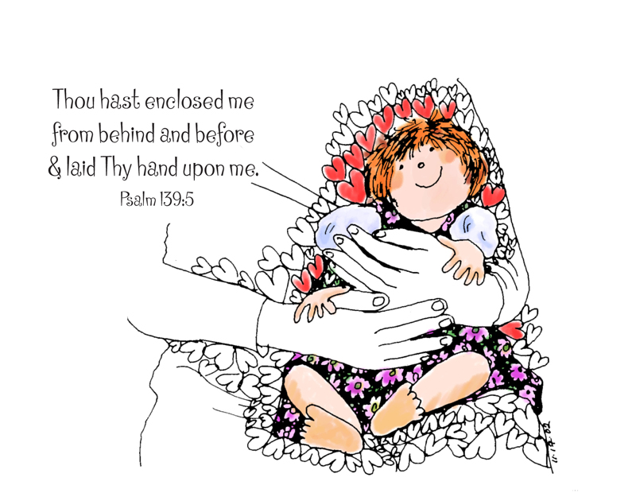

12 Yardville-Hamilton Square Road

Yardville, NJ 08620
(609) 585-5770
(609) 585-5674 fax
www.upcnj.org
July 23, 2017

WELCOME
Welcome! You have come to hear the Word of God, and you shall hear it read and preached. But we hope that by hearing it, you will also meet the Word of God, the Living Word, Jesus, our Master and Savior. And we pray that you will leave our church equipped to serve him more faithfully and effectively.

SERVICE FOR THE LORD’S DAY

July 23, 2017

PRELUDE “Close to Thee” arr. S. Vall

ANNOUNCEMENTS

PRAYER HYMN “Precious Lord, Take My Hand” 404
Precious Lord, take my hand,
Lead me on, help me stand;
I am tired, I am weak, I am worn;
Through the storm, through the night,
Lead me on to the light;
Take my hand, precious Lord, lead me home.

WE COME TO WORSHIP GOD
CALL TO WORSHIP
Leader: From the moment we open our eyes each morning,
until we close them at night, God is with us.
People: There is no one like you, our God!
Leader: In times when we are surrounded with struggles,
in all the surprising places we find hope, Jesus is with us.
People: There is no one like you, our Brother and Savior!
Leader: When we feel orphaned by the world,
when we are welcomed into faith's family, the Holy Spirit is with us.
People: There is no one like you, Witnessing Spirit!

All: Let us worship our incomparable God!

*HYMN “Come, Thou Almighty King” 139

CALL TO CONFESSION

PRAYER OF CONFESSION
Merciful God, as your children, we long to grow to spiritual maturity, and to be weaned from the elementary teachings of our faith. We desire to live as disciples who can be entrusted with the full measure of the gospel. We confess that we often avoid such growth. We prefer the simplicity of childhood rather than the complex tensions of adulthood. We would rather remain comfortable than embrace the pain of change. We pretend that complacency and maintaining the status quo is something other than slow death. Forgive us, Lord. Renew within us the desire and commitment to be fully alive to you, to ourselves and to one another as faithful and mature followers of Christ. Amen.
SILENT PRAYER
ASSURANCE OF PARDON

*GIVE GLORY TO GOD “Glory Be to the Father” 577
Glory be to the Father, and the Son, and the Holy Ghost;
As it was in the beginning, is now, and ever shall be,
World without end. Amen.
As it was in the beginning, is now, and ever shall be,
World without end. Amen.
Amen. Amen. Amen. Amen.
Amen. Amen. Amen.

PRAYER FOR ILLUMINATION

OLD TESTAMENT LESSON Psalm 139:1-12, 23-24
¹ O Lord, you have searched me and known me.
² You know when I sit down and when I rise up; you discern my thoughts from far away.
³ You search out my path and my lying down, and are acquainted with all my ways.
⁴ Even before a word is on my tongue, O Lord, you know it completely.
⁵ You hem me in, behind and before, and lay your hand upon me.
⁶ Such knowledge is too wonderful for me; it is so high that I cannot attain it.
⁷ Where can I go from your spirit? Or where can I flee from your presence?
⁸ If I ascend to heaven, you are there; if I make my bed in Sheol, you are there.
⁹ If I take the wings of the morning and settle at the farthest limits of the sea,
¹⁰ even there your hand shall lead me, and your right hand shall hold me fast.
¹¹ If I say, "Surely the darkness shall cover me, and the light around me become night,"
¹² even the darkness is not dark to you; the night is as bright as the day,
for darkness is as light to you.
²³ Search me, O God, and know my heart; test me and know my thoughts.
²⁴ See if there is any wicked way in me, and lead me in the way everlasting.

A TIME WITH CHILDREN “Ten Thousand Hours” Rev. Jean B. Pinto

SPECIAL MUSIC “Near to the Heart of God” Cleland B. MacAfee Soloist – Warren Briggs

NEW TESTAMENT LESSON Romans 8:12-25
¹² So then, brothers and sisters, we are debtors, not to the flesh, to live according to the flesh— ¹³ for if you live according to the flesh, you will die; but if by the Spirit you put to death the deeds of the body, you will live. ¹⁴ For all who are led by the Spirit of God are children of God. ¹⁵ For you did not receive a spirit of slavery to fall back into fear, but you have received a spirit of adoption. When we cry, "Abba! Father!" ¹⁶ it is that very Spirit bearing witness with our spirit that we are children of God, ¹⁷ and if children, then heirs, heirs of God and joint heirs with Christ—if, in fact, we suffer with him so that we may also be glorified with him.
¹⁸ I consider that the sufferings of this present time are not worth comparing with the glory about to be revealed to us. ¹⁹ For the creation waits with eager longing for the revealing of the children of God; ²⁰ for the creation was subjected to futility, not of its own will but by the will of the one who subjected it, in hope ²¹ that the creation itself will be set free from its bondage to decay and will obtain the freedom of the glory of the children of God. ²² We know that the whole creation has been groaning in labor pains until now; ²³ and not only the creation, but we ourselves, who have the first fruits of the Spirit, groan inwardly while we wait for adoption, the redemption of our bodies. ²⁴ For in hope we were saved. Now hope that is seen is not hope. For who hopes for what is seen? ²⁵ But if we hope for what we do not see, we wait for it with patience.

SERMON “Good Pain? Really?” Rev. Jean B. Pinto
MOMENT FOR QUIET REFLECTION

*HYMN “Take Up Your Cross, the Savior Said” 393
Joys and concerns may be written on the pew cards and given to the ushers during this hymn. They will be shared during the prayers of the people, unless you mark them confidential.

WE RESPOND TO GOD’S WORD

* AFFIRMATION OF FAITH The Apostles’ Creed”
I believe in God the Father Almighty, Maker of Heaven and earth. And in Jesus Christ his only Son our Lord; who was conceived by the Holy Ghost, born of the Virgin Mary, suffered under Pontius Pilate, was crucified, dead, and buried; he descended into hell; the third day he rose again from the dead; he ascended into heaven, and sitteth on the right hand of God the Father Almighty; from thence he shall come to judge the quick and the dead.
I believe in the Holy Ghost; the holy catholic church; the communion of saints; the forgiveness of sins; the resurrection of the body; and the life everlasting. Amen.
PRAYERS OF THE PEOPLE AND THE LORD’S PRAYER
CONGREGATIONAL RESPONSE
Hear our prayer, O Lord, Hear our prayer, O Lord
Incline Thine ear to us, And grant us Thy peace.

CALL FOR THE OFFERING

OFFERTORY “Master, No Offering Costly and Sweet” arr. S. Scott

*WE GIVE PRAISE AND THANKS TO GOD (tune # 455)
Praise God from whom all blessings flow; Praise Him all creatures here below;
Alleluia, Alleluia. Praise Him above ye heav'nly host; Praise Father Son and Holy Ghost.
Alleluia! Alleluia! Alleluia! Alleluia! Alleluia!

*PRAYER TO DEDICATE OUR GIFTS
Your steadfast love is but one of the many gifts you pour into us. Our offerings are but a part of the ways in which we can serve you and your people. Bless them, and bless us, to ministries of healing and hope. Amen.

*HYMN “Love Divine, All Loves Excelling” 376

*WE RECEIVE GOD’S BLESSING Leader: By the word of our Lord the heavens were made.
People: By the spirit of our Lord was life begun.
Leader: By the wisdom of our Lord his laws were laid.
People: By the love of our Lord was born his Son.
Leader: By the grace of our Lord mankind was saved.
People: By the power of our Lord the victory was won.
Leader: With this spirit, word, wisdom, love, grace and power,
People: let us go forth into the world to proclaim your good news

All: of hope and comfort wherever there is pain. Amen.

POSTLUDE “Praise to the Living God” Ritter
*Those who are able may stand.
Liturgist: Rhea Mucha
Flowers: Given In Loving Memory of Larry Comfort by Joan Reid; In Loving Memory of Harry Steele by the Machin’s
Greeters & Ushers: Ginny Demeter and Jean Malloy

UPCOMING EVENTS July 23rd – July 30th
Sunday---July23rd 9:30 am E3 Worship Service
11:00 am Traditional Worship
Monday July 24th 12:00 pm AA
8:00 pm NA
Tuesday—July 25th 12:00 pm AA
Wednesday July 26th 7:00 pm AA
Thursday—July 27th 8:00 pm AA
Friday-------July 28th 8:00 pm AA
Sunday—July 30th 9:30 am E3 Worship
11:00 am Traditional Worship

There are large print bulletins available. Please see an usher if you need this service.

Sing – Play – Move! Praise the Lord! - Summer is almost here! Music is all around us the buzzing of insects, grass and flowers blowing in the breeze. It is also a time of singing, playing moving through dance to share our talents in a less formal way! Please consider your talents and ability to share them during our service at 11:00 am.! We are all so appreciative! A sign-up sheet is placed in the Narthex for name sign-up! Thank you!

Today’s Special Music – Is sung by Warren Briggs. He is an avid singing bass member of our Choir. Cleland MacAfee, both Choir Director and Presbyterian minister at Park College (now Park University, Parkville, Missouri) wrote this beautiful, quiet, third person gospel hymn upon the deaths of two infant nieces staying at his home at the time (1903) from diphtheria.

PRAYER REQUESTS
Healing for: Maria, Pam, Paige, Wayne., John Borek, Pam and Dan Rose; Ron, Bill, Kyle, Lenny, Pat, Cathy, Sally, Carolyn McPhee, Pat Anthony; Connie Davis and Andrea Pinto all undergoing treatment for cancer; Esther Whitley – colon cancer; Tom Zeyack Sr. – liver cancer; Nickie & family – healing from a car accident; Jim Krika – healing from severe pain all over body; Dot Bracaloni; Susan Anthony; Carol Francis – in St. Lawrence Rehab; Al & Carol D/Amico; Scott Rose; Bob D’Angelo; Val Zamborsky; Carrie and Esther – healing from breast cancer surgery; Helen Fisher – suffering from Alzheimers as well as prayers of support for the extended Fisher family Frank Kostar-heart issues; Marilyn Kostar – health issues and coping with Frank; Girja Singh – strength for future operation; Dixie & Dave Senft – medical issues; Healing for Mike McHugh – infection and hospitalized, and Nancy McHugh – strength for dealing with illness and an aging parent; Bob Conner – healing from foot tendon surgery; Arlene – healing from knee replacement surgery; Mrs. Walter – recovering from broken hip and broken rib; Debbie Furchak, their daughter who is caring for both her parents; Cindy – having knee replacement surgery this Thursday, 7/19.
Concern & Comfort – for the family of Jeff Pachuta.
Comfort – Bereaved family of Venna Bray (friend of Virginia Benck)
Concern – Control of seizures for James Bade and wisdom for the doctors to successfully treat his seizures. He is seeing specialists for further treatment; Laura Mraz for finding a new job.

Our Mission Statement
We are called by Jesus Christ and empowered by the Holy Spirit to celebrate and share the love of God with grace and joy.
Gracefully and joyfully we seek to share our gifts in the community through:
Open Doors
Diverse Worship
Innovative Education
Creative Mission
Dynamic Service

OUR CONGREGATION IN MISSION
Because of your stewardship commitment, the United Presbyterian Church is supporting the ministries of:
- The Presbyterian Church (U.S.A.) through Monmouth Presbytery; the Synod of the Northeast, and the General Assembly.
- Mobile Meals of Hamilton Township
- Princeton Theological Seminary Scholarship Fund
- Trenton Area Habitat for Humanity
- Trenton Area Rescue Mission
- Presbyterian Camp at Johnsonburg
- Trenton Area Soup Kitchen
- Pearson Memorial Food Bank
- Womanspace
- Homefront

CHURCH STAFF
Ministers: All the members of the Congregation
Pastor: Rev. Jean B. Pinto (737-8011) jeanbpinto@gmail.com
Pastors Emeriti: Rev. Terry E. Fouse and Rev. John H. Milne
Organist: Marilyn Machmer
Choir Director: Michael Mraz
Church Secretary: Michael Mraz
Prayer Chain: Daytime: Carol Heberling (298-2594); Betty Reinert (585-5770)
Evening: Gail Fouse (585-3248); Joyce Vaughn (888-1187)

