UNITED PRESBYTERIAN CHURCH

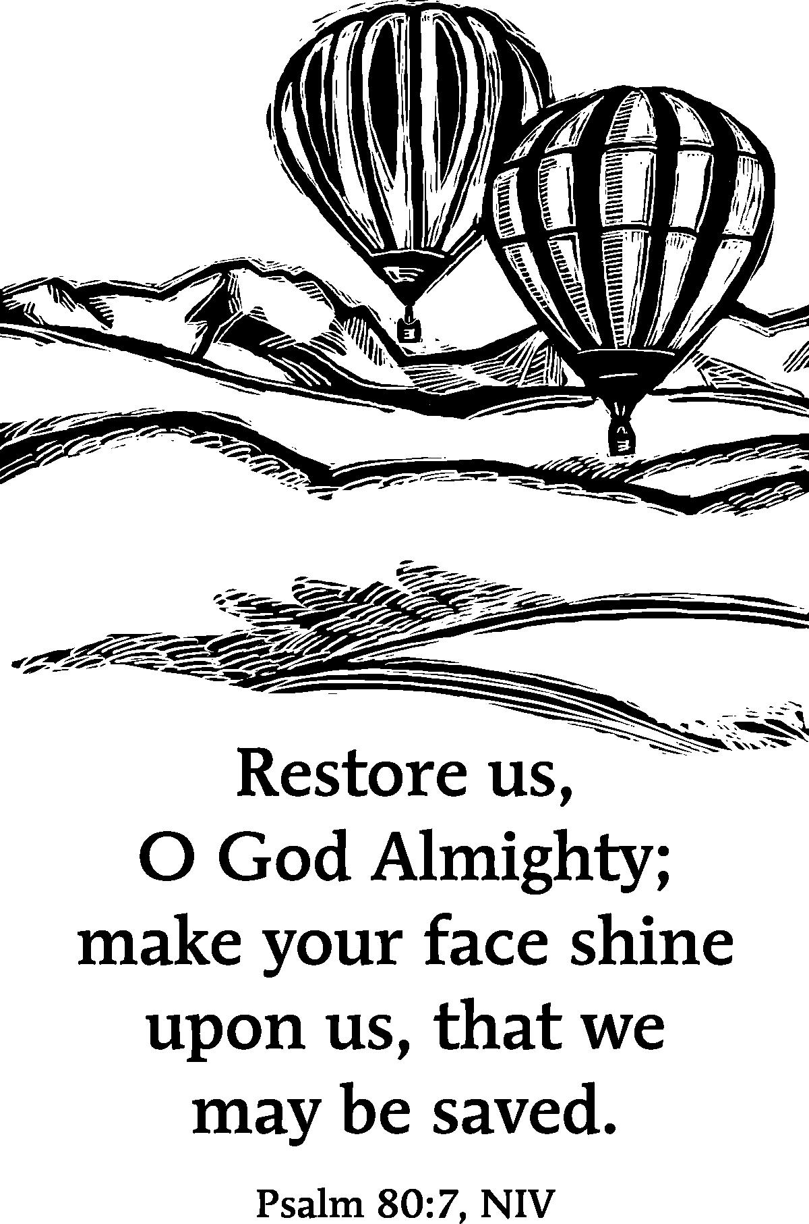

12 Yardville-Hamilton Square Road

Yardville, NJ 08620
(609) 585-5770
(609) 585-5674 fax

www.upcnj.org
November 30, 2014

WELCOME
Welcome! You have come to hear the Word of God, and you shall hear it read and preached. But we hope that by hearing it, you will also meet the Word of God, the Living Word, Jesus, our Master and Savior. And we pray that you will leave our church equipped to serve him more faithfully and effectively.

SERVICE FOR THE LORD’S DAY

November 30, 2014

ADVENT HYMN SING

ANNOUNCEMENTS

WE COME TO WORSHIP GOD

ADVENT CANDLE LIGHTING CEREMONY
Leader: As our days grow shorter and our nights longer,
we who are people of faith turn to symbols
such as candles, evergreens and wreaths
to proclaim our belief in the unquenchable light.
In hopeful anticipation, we prepare for the coming of the Reign of God.
All: We open our hearts to the Word in the words.

Leader: A reading from the Prophet Isaiah, Chapter 64, verses 1 to 9.
1 O that you would tear open the heavens and come down, so that the mountains would quake at your presence— 2 as when fire kindles brushwood and the fire causes water to boil— to make your name known to your adversaries, so that the nations might tremble at your presence! 3 When you did awesome deeds that we did not expect, you came down, the mountains quaked at your presence. 4 From ages past no one has heard, no ear has perceived, no eye has seen any God besides you, who works for those who wait for him. 5 You meet those who gladly do right, those who remember you in your ways. But you were angry, and we sinned; because you hid yourself we transgressed. 6 We have all become like one who is unclean, and all our righteous deeds are like a filthy cloth. We all fade like a leaf, and our iniquities, like the wind, take us away. 7 There is no one who calls on your name, or attempts to take hold of you; for you have hidden your face from us, and have delivered us into the hand of our iniquity. 8 Yet, O Lord, you are our Father; we are the clay, and you are our potter; we are all the work of your hand. 9 Do not be exceedingly angry, O Lord, and do not remember iniquity forever. Now consider, we are all your people.
All: As we begin our journey to the light,
we confess that our lives have not always been lived
in ways pleasing to God.
Our shame has left us feeling distant from
the One who is both Mother and Father to us all,
the One in whose hands we are like clay.
Yet even now, our longing for the One
who tears open the heavens and comes down
kindles a fire in our soul.
Even now as we wait, we dare to hope.
One: We who are pregnant with anticipation
feel hope rise up within us.
And so we light this first candle
and name it Hope.

*HYMN “Prepare the Way” 13

CALL TO CONFESSION

PRAYER OF CONFESSION
Father, we have sinned against you. While we have lied to our brother or gossiped about our sister, it is you whose heart we have broken. You, who have given us life, who have demonstrated unconditional love and mercy; you are the one we have failed. Yet, our failure does not ruin us. We know that you will continue to love us. We ask once again for your grace and forgiveness. And may your loving-kindness move us away from sin and always toward your Son. Thank you, Father. Amen.

SILENT PRAYER

ASSURANCE OF PARDON

*GIVE GLORY TO GOD “Joy to the World” verse 1 40
Joy to the world! The Lord is come:
Let earth receive her King;
Let every heart prepare Him room,
And heaven and nature sing,
And heaven and nature sing,
And heaven, and heaven and nature sing.
A TIME WITH CHILDREN “So Sorry” Rev. Jean Pinto

ANTHEM

PRAYER FOR ILLUMINATION

LESSON FROM THE PSALMS Pg. 510 Psalm 80:3-7, 17-19
3 Restore us, O God;
let your face shine, that we may be saved.
4 O Lord God of hosts,
how long will you be angry with your people’s prayers?
5 You have fed them with the bread of tears,
and given them tears to drink in full measure.
6 You make us the scorn of our neighbors;
our enemies laugh among themselves.
7 Restore us, O God of hosts;
let your face shine, that we may be saved.

17 But let your hand be upon the one at your right hand,
the one whom you made strong for yourself.
18 Then we will never turn back from you;
give us life, and we will call on your name.
19 Restore us, O Lord God of hosts;
let your face shine, that we may be saved.

SERMON “Christians Behaving Badly” Rev. Jean Pinto

MOMENT FOR QUIET REFLECTION

*HYMN “Come, Thou Long-Expected Jesus” 2 Joys and concerns may be written on the pew cards and given to the ushers during this hymn. They will be shared during the prayers of the people, unless you mark them confidential.

WE RESPOND TO GOD’S WORD

*AFFIRMATION OF FAITH—The Apostles’ Creed
I believe in God the Father Almighty, Maker of Heaven and earth. And in Jesus
Christ his only Son our Lord; who was conceived by the Holy Ghost, born of the Virgin Mary, suffered under Pontius Pilate, was crucified, dead, and buried; he descended into hell; the third day he rose again from the dead; he ascended into heaven, and sitteth on the right hand of God the Father Almighty; from thence he shall come to judge the quick and the dead.
I believe in the Holy Ghost; the holy catholic church; the communion of saints; the forgiveness of sins; the resurrection of the body; and the life everlasting. Amen.

PRAYERS OF THE PEOPLE AND THE LORD’S PRAYER

CONGREGATIONAL RESPONSE
Hear our prayer, O Lord, Hear our prayer, O Lord
Incline Thine ear to us, And grant us Thy peace.

CALL FOR THE OFFERING

OFFERTORY

*WE GIVE PRAISE AND THANKS TO GOD (tune # 455)
Praise God from whom all blessings flow; Praise Him all creatures here below;
Alleluia, Alleluia. Praise Him above ye heav'nly host; Praise Father Son and Holy Ghost.
Alleluia! Alleluia! Alleluia! Alleluia! Alleluia!

*PRAYER TO DEDICATE OUR GIFTS
As we wait together for the day of Christ’s coming, may these, our offerings, be signs of God’s fruit. In our giving, may we grow in the compassion and justice of Jesus, in whose name we pray and whose coming we celebrate. Amen.

*HYMN “O Come, O Come, Emmanuel” 9

*WE RECEIVE GOD’S BLESSING

POSTLUDE

*Those who are able may stand.

Greeters & Ushers: Kathy Thewes and Joyce Vaughn

Liturgist: Karl Peterson

UPCOMING EVENTS November 30th – December 7th

Sunday—November 30th: 9:30 am E3 Worship
9:30 am Adult Sunday School
10:45 am Advent Hymn Sing
11:00 am Traditional Worship
Monday—December 1st: 7:00 pm Member Care Committee
Tuesday—December 2nd: 7:00 pm Education Committee
Wednesday—December 3rd: 6:00 pm Memorial and Endowment Committee
7:00 pm Stewardship Ministry Team-Finances
Thursday—December 4th: 7:30 pm Choir
Saturday—December 6th: 10:00 am Cantata Rehearsal
Sunday—December 7th: 9:30 am E3 Worship
9:30 am Adult Sunday School
10:15 am Coffee Hour
10:45 am Advent Hymn Sing
11:00 am Traditional Worship
6:00 pm Youth Group

There are large print bulletins available. Please see an usher if you need this service.01

This year’s Adult Sunday School Class has selected 14 different topics to help us learn more about the Bible and Jesus’ teachings. Interested? Want a place to discuss and explore?? Pick one or all. Then come to the Bertolet Lounge on Sunday mornings at 9:30. The coffee is on.
 | Teacher | Topic
Nov 30, Dec 7, 14, 28, Jan 4, 11 | Tony | Book of John
January 18, 25, Feb 1, 8, 15, 22 | Curly | The Beatitudes of Jesus
March 1 | Jean M | Christian Fasting
March 8, 15, 22 | Jean Pinto | Interpreting the Bible
Mar 29, April 5 | Jean M | Book of Colossians
April 12 | Jean Pinto | Caring for People with Alzheimer's
April 19 | Peggy | Is there Life after Death?
April 26, May 3 | Tony | Book of Ephesians
May 10, 17 | Jean M | Book of Joshua
May 24 | Bill | Church Reformation

All are welcome to join the choir as we present our Christmas cantata “Season of Wonders” on Sunday, December 14th, during the 11 a.m. worship service. Weekly rehearsals began on Thursday, Oct. 2nd at 7:30 in the sanctuary (there will be a dress rehearsal on Sat. Dec. 6th at 10 a.m.). There are listening CDs available to assist in learning the cantata. “Season of Wonders” is filled with classic carols as well as newly composed anthems, this hopeful work shines new light upon the miracles surrounding the birth of Jesus. In performing this work, different "messengers" announce the various narrations. Miracles and wonders are meant to be shared. The events that unfold are a series of wonders that are meant to be shared with the world so all may know the good news!
The Survivors Senior Group will meet at Villa Romanza (formerly Giovi's), Route 130 South, Yardville on Wed., Dec. 10, 2014 at 11:30 a.m. for our Christmas lunch. Following our lunch we have a tour of the Kuser Farm Mansion, 390 Newkirk Ave., Hamilton at 2:00 p.m. The
mansion will be decorated for the Christmas and will be a great way to get into the holiday spirit. If you plan to attend please make your reservation with Rita Peterson at 259-7256 or email ritapete@optonline.net. If you are in need of a ride to the restaurant please feel free to give me a call. All seniors of the church and their friends are welcome to join the Survivors for a great lunch, tour and wonderful holiday fellowship.

Orders for gift cards are now being accepted for holiday giving. Forms are available on the table in the Narthex or from the church office. When ordering, please indicate the date you need the cards on the top of the form. Please have your orders into the church office by December 12th.

Our mission focus for the month of November is the Pearson Memorial Church Food Bank. All donations earmarked for Pearson Memorial in November will be used to support the work of the Food Bank.

If you have not yet had the opportunity to pledge for 2015, please prayerfully consider your pledge to the 2015 LOVE GIVES campaign. Together we can support Christ’s work so much more effectively than we can alone.

PRAYER REQUESTS

Healing George Edwards; Pat Howell; Patty Hobson Henry; Nando Avila; John; Maria; Melissa; Dottie; Donna; Jodi Adelmann (breast cancer); Lew Thorn; Ruth Sletvold (impending surgery); Bill Hall (head, shoulder and rib injuries from motorcycle accident); Howard Stoeckel (RWJ recovering from surgery for broken leg); and Carolyn Reynolds whose surgery has been rescheduled for Nov. 24th due to an illness).
Comfort for the Rossi family upon the loss of their father; and also for Peggy Ayres’ family.
Prayers for Doris Thorn as the primary caregiver for her husband, Lew; prayers for MaryAnn and Anita for successful treatment of their cancers; and prayers for a job for a LaCrosse family member with his own family.

Our Mission Statement

We are called by Jesus Christ and empowered by the Holy Spirit to celebrate and share the love of God with grace and joy.
Gracefully and joyfully we seek to share our gifts in the community through:

Open Doors
Diverse Worship
Innovative Education
Creative Mission
Dynamic Service

OUR CONGREGATION IN MISSION
Because of your stewardship commitment, the United Presbyterian Church is supporting the ministries of:
- The Presbyterian Church (U.S.A.) through Monmouth Presbytery; the Synod of the Northeast, and the General Assembly.
- Mobile Meals of Hamilton Township
- Princeton Theological Seminary Scholarship Fund
- Trenton Area Habitat for Humanity
- Trenton Area Rescue Mission
- Presbyterian Camp at Johnsonburg
- Trenton Area Soup Kitchen
- Pearson Memorial Food Bank
- Womanspace
- Homefront
- Trenton Area Campus Ministries

CHURCH STAFF
Ministers: All the members of the Congregation
Pastor: Rev. Jean B. Pinto (737-8011) jeanbpinto@comcast.net
Pastors Emeriti: Rev. Terry E. Fouse and Rev. John H. Milne
Organist: Michael Mraz
Choir Director: Marilyn Machmer
Church Secretary: Betty Reinert
Prayer Chain: Daytime: Carol Heberling (298-2594); Betty Reinert (585-5770)
Evening: Gail Fouse (585-3248); Joyce Vaughn (888-1187)

