UNITED PRESBYTERIAN CHURCH

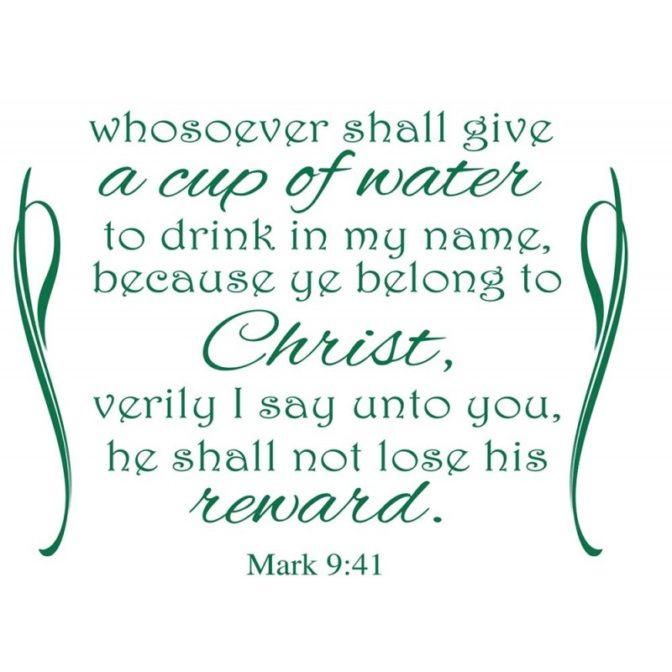

12 Yardville-Hamilton Square Road

Yardville, NJ 08620
(609) 585-5770

www.upcnj.org
New Email Address: office.upcnj@gmail.com

September 30, 2018

WELCOME!

Welcome! You have come to hear the Word of God, and you shall hear it read and preached. But we hope that by hearing it, you will also meet the Word of God, the Living Word, Jesus, our Master and Savior. And we pray that you will leave our church equipped to serve him more faithfully and effectively.

SERVICE FOR THE LORD’S DAY

September 30, 2018

PRELUDE “Pastorale” arr. S. Watson

PRAYER HYMN “Breathe on Me, Breath of God” 316

Breathe on me, Breath of God, fill me with life anew,
That I may love what Thou dost love, and do what Thou wouldst do.
Breathe on me, Breath of God, until my heart is pure,
Until with Thee I will one will, to do and to endure.

WE COME TO WORSHIP GOD

CALL TO WORSHIP

Leader: We will walk this day with you, O God, and you will walk with us,
People: gathering us into a community to pray for one another in all things.

Leader: We will walk this day with you, O Christ, and you will walk with us.

People: calling us to follow you, helping us to set aside all which holds us back.
Leader: We will walk this day with you, O Spirit, and you will walk with us,
People: sending us out, side by side, to serve those cast aside by the world.

Leader: Together let us worship the living, loving God.

*HYMN “Immortal, Invisible God Only Wise” 263

CALL TO CONFESSION

PRAYER OF CONFESSION
O God, When sin and death hover around us, like famished vultures, you fill us with new strength so they cannot feed on us; when our bitterness clamps tight around our hearts with its steel-like teeth, you pry us loose with your scarred hands so we might walk in faith with you; when we stack our hurts one on top of another, like kindling wood, ready to set the match of our anger to the pile, you pour your Spirit of forgiveness upon them, until they are soaked so thoroughly, nothing can ignite them. Our help, our hope, our life, and our peace are truly found in the name of our Lord and Savior, Jesus Christ. Amen!

SILENT PRAYER

ASSURANCE OF PARDON

*GIVE GLORY TO GOD “Glory Be to the Father” 577

Glory be to the Father, and the Son, and the Holy Ghost;
As it was in the beginning, is now and ever shall be,
World without end. Amen.
As it was in the beginning, is now and ever shall be,
World without end. Amen.
Amen, Amen, Amen, Amen.
Amen, Amen, Amen.

PRAYER FOR ILLUMINATION

GOSPEL LESSON Pg. 877
Mark 9:38-50 (NSRV)
³⁸ John said to him, “Teacher, we saw someone casting out demons in your name, and we tried to stop him, because he was not following us.” ³⁹ But Jesus said, “Do not stop him; for no one who does a deed of power in my name will be able soon afterward to speak evil of me. ⁴⁰ Whoever is not against us is for us. ⁴¹ For truly I tell you, whoever gives you a cup of water to drink because you bear the name of Christ will by no means lose the reward. ⁴² “If any of you put a stumbling block before one of these little ones who believe in me, it would be better for you if a great millstone were hung around your neck and you were thrown into the sea. ⁴³ If your hand causes you to stumble, cut it off; it is better for you to enter life maimed than to have two hands and to go to hell, to the unquenchable fire. ⁴⁵ And if your foot causes you to stumble, cut it off; it is better for you to enter life lame than to have two feet and to be thrown into hell. ⁴⁷ And if your eye causes you to stumble, tear it out; it is better for you to enter the kingdom of God with one eye than to have two eyes and to be thrown into hell, ⁴⁸ where their worm never dies, and the fire is never quenched. ⁴⁹ “For everyone will be salted with fire ⁵⁰ Salt is good; but if salt has lost its saltiness, how can you season it? Have salt in yourselves, and be at peace with one another.”

ANTHEM “Lord, Listen to Your Children Praying” K. Medina

EPISTLE LESSON Pgs.1056 - 1057 James 5:13-20
(NSRV)
¹³ Are any among you suffering? They should pray. Are any cheerful? They should sing songs of praise. ¹⁴ Are any among you sick? They should call for the elders of the church and have them pray over them, anointing them with oil in the name of the Lord. ¹⁵ The prayer of faith will save the sick, and the Lord will raise them up; and anyone who has committed sins will be forgiven. ¹⁶ Therefore confess your sins to one another, and pray for one another, so that you may be healed. The prayer of the righteous is powerful and effective. ¹⁷ Elijah was a human being like us, and he prayed fervently that it might not rain, and for three years and six months it did not rain on the earth. ¹⁸ Then he prayed again, and the heaven gave rain and the earth yielded its harvest. ¹⁹ My brothers and sisters, if anyone among you wanders from the truth and is brought back by another, ²⁰ you should know that whoever brings back a sinner from wandering will save the sinner’s soul from death and will cover a multitude of sins.

SERMON “Presbyterians Can Always Come Home” Rev. Barbara J. Hicks

MOMENT FOR QUIET REFLECTION

*HYMN “Jesus, the Very Thought of Thee” 310

(Joys and concerns may be written on the pew cards and given to the ushers during this hymn. They will be shared during the prayers of the people, unless you mark them confidential.)

WE RESPOND TO GOD’S WORD

*AFFIRMATION OF FAITH - The Apostle’s Creed

I believe in God the Father Almighty, Maker of Heaven and earth. And in Jesus Christ his only Son our Lord; who was conceived by the Holy Ghost, born of the Virgin Mary, suffered under Pontius Pilate, was crucified, dead, and buried; he descended into hell; the third day he rose again from the dead; he ascended into heaven, and sitteth on the right hand of God the Father Almighty; from thence he shall come to judge the quick and the dead.

I believe in the Holy Ghost; the holy catholic church; the communion of saints; the forgiveness of sins; the resurrection of the body; and the life everlasting. Amen.

PRAYERS OF THE PEOPLE AND THE LORD’S PRAYER

CONGREGATIONAL RESPONSE

Hear our prayer, O Lord, Hear our prayer, O Lord
Incline Thine ear to us, And grant us Thy peace.

WE PRESENT TO GOD OUR GIFTS AND OFFERINGS

OFFERTORY “Lord, Keep Us Steadfast in Your Word” arr. P. Manz

*WE GIVE PRAISE AND THANKS TO GOD tune # 455

Praise God from whom all blessings flow; Praise Him all creatures here below;
Alleluia, Alleluia.
Praise Him above ye heav'nly host; Praise Father Son and Holy Ghost.
Alleluia! Alleluia! Alleluia! Alleluia! Alleluia!

*PRAYER TO DEDICATE OUR GIFTS

All that we give is first a gift from you, O God. It is a joy to invest in the mission of the church, both as a gathered community in this place and as a scattered people who day by day offer a cup of cold water in Christ’s name to people who are thirsty. May our offering of this treasure, and of our time and our talent bring you the glory and honor that you so richly deserve from us. Amen.

*HYMN “The Church’s One Foundation” 442

*WE RECEIVE GOD’S BLESSING

POSTLUDE “Largo” J. Stanley

*Those who are able may stand.

**********

UPCOMING EVENTS
September 30th through October 7th, 2018

Sun., 9/30 | 9:30 am E3 Worship Svc  9:30 am Adult Sun. School  11:00 am Traditional Svc  6:00 pm Youth Group |  | Thurs., 10/4 | 7:30 pm Choir Rehearsal  (Christmas Cantata)  8:00 pm A/A
Mon., 10/1 | 12:00 pm A/A  7:00 pm N/A  7:00 pm Boy Scouts |  | Fri., 10/5 | 8:00 pm A/A
Tues., 10/2 | 10:00 am UPC Women  12:00 pm A/A  5:00 pm Ed. Committee |  | Sat., 10/6 | 9 am – 12 pm Prison Ministry
Wed., 10/3: | 8:00 pm A/A |  | Sun., 10/7 | PIE SALE STARTS!  9:30 am E3 Worship Service  9:30 am Adult Sunday School  11:00 am Traditional Svc  6:00 pm Youth Group

Greeters & Ushers are Nancy McHugh & Virginia Benck

Large print bulletins are available. Please see an usher if you need this service.

We Welcome the Rev. Barbara J. Hicks to our pulpit today. Rev. Hicks was born and raised in suburban Philadelphia. She received a BA in History from Temple University and a M.Div. from Princeton Theological Seminary. In the course of her 34 years in ministry, Barbara has served in various congregations. She is the Pastor Emerita of Lakewood’s Hope Presbyterian Church where she served for over 17 years. Barbara is widowed with 2 adult children and one granddaughter.

Mission Spotlight - Princeton Theological Seminary prepares women and men to serve Jesus Christ in ministries marked by faith, integrity, scholarship, competence, compassion, and joy, equipping them for leadership worldwide in congregations and the larger church, in classrooms and the academy, and in the public arena. All of the money donated to Mission during the month of August will support Princeton Seminary. Please be generous and thereby help train the next generation of future church leaders.

Christmas Cantata Choir* rehearsals begin Thurs., Oct. 4th at 7:30 p.m. All are welcome to join the choir for the new Christmas Cantata “Let the Whole World Sing”. The cantata will be presented on Dec. 16, 2018 (Third Sunday of Advent) during the 11 a.m. worship service. There will be a dress rehearsal on Sat., Dec. 8th at 10 a.m. in the sanctuary. Cantata books and listening CDs are now available; please see Choir Director Marilyn Machmer.
*PLEASE NOTE THE CHRISTMAS CANTATA CHOIR PRACTICE FOR THURS., OCT. 18th WILL BE HELD IN THE NURSERY!

The Survivors Senior Group will meet in church parking lot promptly on Wed., Oct. 10th at 9 a.m. We will tour the “Whitesbog Historic Village” in Brown Mills, NJ. Whitesbog was founded in 1857 and restored to a 1900’s village - the historic site of cranberry and blueberry farms. Trip cost will be $6 per person. Afterwards, we will enjoy lunch at the Vincetown Diner, Rt. 206 S., Vincetown, NJ. All UPC seniors and friends are most welcome to join us for a wonderful tour and lunch. Please R.S.V.P. to Rita Peterson @ (609) 259-7256 or email ritapete@optonline.net.

The Survivors Senior Group will carpool on Sun., Dec. 9th at 1p.m. to United Methodist Church, Broad St. & Lawrence St., Burlington, NJ. We will attend “The Christmas Carol” presented by Gerald Charles Dickens (great-great grandson of author Charles Dickens). Trip cost will be $15 per person (non-refundable). Afterwards, we will enjoy an early dinner at Fratellis Italian Restaurant, 1414 Rte. 130 N., Burlington, NJ. Please R.S.V.P. as soon as possible with Rita Peterson @ (609) 259-7256 or email ritapete@optonline.net.

The United Presbyterian Women will hold their monthly meeting on Tues., Oct. 2nd, 2018 at 10 a.m. in the church nursery. Coffee/fellowship/bible study and business meeting to follow. Our focus will be Chapter 7, ‘Praying for God’s Will’, from the book Discovering God’s Will for Your Life. All women are cordially invited to join us!

PRAYER REQUESTS
^{* -} Please pray as listed:
Art – pray for heart surgery
Anthony, Pat – pray for testing results
Betty Lou – pray for healing
Bock, Dr. John – pray for healing from throat cancer
Borek, John – pray for healing from cancer
Cook, Dr. Jeff – pray for healing from cancer
Dan & Pam – pray for healing
D’Amico, Carol & Al – pray for healing
Dinah – pray for sinus surgery
Donna – pray for severe infection
Family suffering from father’s addiction
HURRICANE FLORENCE – Thankful for prayers answered for those affected by storm
Kostar, Frank & Marilyn – pray for healing
McHugh Family –pray for healing, comfort, concern, and thanksgiving
Michelle – pray for relief from allergies and upset stomach

*Prayer requests will remain in effect for a one- week period. Therefore, please advise duration of prayer request. Thank you so much and God bless.

OUR MISSION STATEMENT

We are called by Jesus Christ and empowered by the Holy Spirit to celebrate and share the love of God with grace and joy.

OUR CONGREGATION IN MISSION

Your generous stewardship commitment to the United Presbyterian Church provides support
To ministries of:
The Presbyterian Church (USA) thru Monmouth Presbytery; the Synod of the N.E., and the General Assembly |  | Presbyterian Camp at Johnsonburg
Mobile Meals of Hamilton Township |  | Trenton Area Soup Kitchen
Princeton Theological Seminary Scholarship Fund |  | Womanspace
Trenton Area Habitat for Humanity |  | Homefront
Trenton Area Rescue Mission |  | Trenton Area Campus Ministries

INVITATION TO CHRISTIAN DISCIPLESHIP

You are invited to make a commitment to follow Jesus Christ as Lord of Life, or to renew your commitment as a Christian Disciple. Please speak to the pastor who will talk and pray with you. If you are looking for a church home we invite you to join this family of faith and service. This is a caring congregation, open to all. Please let us know we can serve you.

CHURCH STAFF
Ministers: All Members of the Congregation

Pastors Emeriti: Rev. Terry E. Fouse and Rev. John H. Milne
Organist/Choir Director: Marilyn Machmer
Church Admin. Asst.: Carol M^{c} Entee

Prayer Chain

Daytime: Carol Heberling Tel. 298-2594 Carol M^{c} Entee Tel. 585-5770
Evening: Gail Fouse Tel. 585-3248 Joyce Vaughn Tel. 888-1187

If you would like to make a written contribution to our worship bulletin, please forward same to the church office no later than Tuesday @ 12 noon. Thank you.

