UNITED PRESBYTERIAN CHURCH

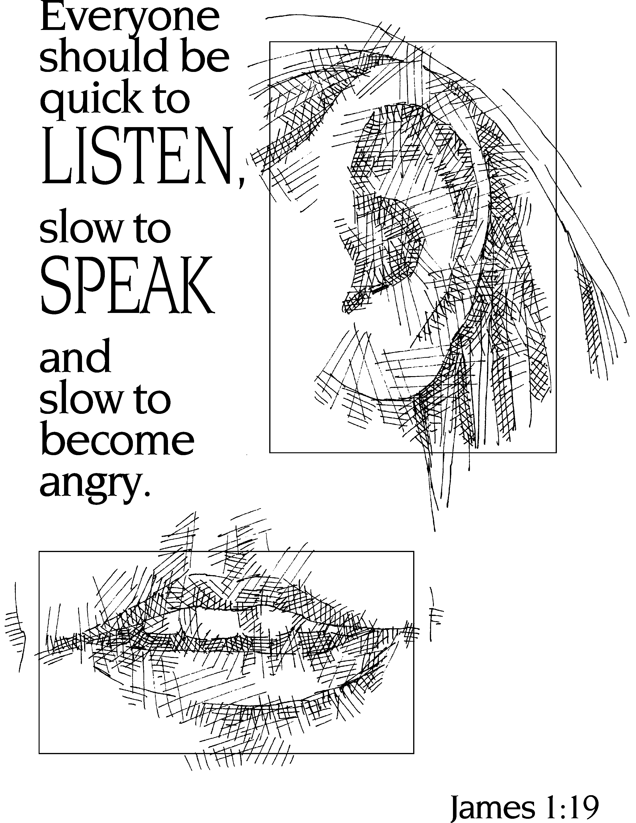

12 Yardville-Hamilton Square Road

Yardville, NJ 08620
(609) 585-5770
(609) 585-5674 fax
www.upcnj.org
September 2, 2018

WELCOME
Welcome! You have come to hear the Word of God, and you shall hear it read and preached. But we hope that by hearing it, you will also meet the Word of God, the Living Word, Jesus, our Master and Savior. And we pray that you will leave our church equipped to serve him more faithfully and effectively.

SERVICE FOR THE LORD’S DAY

September 2, 2018

PRELUDE “The Gift of Love” arr. J. Carter

PRAYER HYMN “Psalm 84” 208
How lovely is your dwelling place, O Lord of hosts.
My soul longs, indeed it faints for the courts of the Lord;
my heart and my flesh sing for joy to the living God.
For a day in your courts is better than a thousand elsewhere.
I would rather be a doorkeeper in the house of my God than live in the tents of wickedness.
O Lord of hosts, happy is everyone who trusts in You.

WE COME TO WORSHIP GOD

CALL TO WORSHIP
Leader: Let us be quick to learn,
People: Slow to speak,
Leader: Quick to love,
People: Slow to anger,
Leader: Quick to share,
People: Slow to exclude.
Leader: Let us not only say we believe,
People: Let us live our belief.
Leader: Together let us worship the living, loving God.

*HYMN “Joyful, Joyful, We Adore Thee” 464

CALL TO CONFESSION

PRAYER OF CONFESSION
O God, why do we so often tear down each other’s hopes? Why are we so quick to condemn others, withdraw from their needs, or turn our backs on them? Forgive us. Allow us to see ourselves and our wounds reflected in the wounds of our neighbors and become more compassionate. Amen.

SILENT PRAYER

ASSURANCE OF PARDON

*GIVE GLORY TO GOD “Glory Be to the Father” 577
Glory be to the Father, and the Son, and the Holy Ghost;
As it was in the beginning, is now and ever shall be,
World without end. Amen.
As it was in the beginning, is now and ever shall be,
World without end. Amen.
Amen, Amen, Amen, Amen.
Amen, Amen, Amen.

PRAYER FOR ILLUMINATION

EPISTLE LESSON Pg. 1054 James 1:17-27
17 Every generous act of giving, with every perfect gift, is from above, coming down from the Father of lights, with whom there is no variation or shadow due to change. 18 In fulfillment of his own purpose he gave us birth by the word of truth, so that we would become a kind of first fruits of his creatures.
19 You must understand this, my beloved: let everyone be quick to listen, slow to speak, slow to anger; 20 for your anger does not produce God’s righteousness. 21 Therefore rid yourselves of all sordidness and rank growth of wickedness, and welcome with meekness the implanted word that has the power to save your souls.
22 But be doers of the word, and not merely hearers who deceive themselves. 23 For if any are hearers of the word and not doers, they are like those who look at themselves in a mirror; 24 for they look at themselves and, on going away, immediately forget what they were like. 25 But those who look into the perfect law, the law of liberty, and persevere, being not hearers who forget but doers who act—they will be blessed in their doing.
26 If any think they are religious, and do not bridle their tongues but deceive their hearts, their religion is worthless. 27 Religion that is pure and undefiled before God, the Father, is this: to care for orphans and widows in their distress, and to keep oneself unstained by the world.

SPECIAL MUSIC “Come to the Table” J.A. Shafferman / S. Kupferschmid
Linda Vandegrift Smyth and Gideon Bernhard, duetists

GOSPEL LESSON Mark 7:1-8, 14-15, 21-23
7 Now when the Pharisees and some of the scribes who had come from Jerusalem gathered around him, ² they noticed that some of his disciples were eating with defiled hands, that is, without washing them. ³ (For the Pharisees, and all the Jews, do not eat unless they thoroughly wash their hands, thus observing the tradition of the elders; ⁴ and they do not eat anything from the market unless they wash it; and there are also many other traditions that they observe, the washing of cups, pots, and bronze kettles.) ⁵ So the Pharisees and the scribes asked him, “Why do your disciples not live according to the tradition of the elders, but eat with defiled hands?” ⁶ He said to them, “Isaiah prophesied rightly about you hypocrites, as it is written,
‘This people honors me with their lips,
but their hearts are far from me;
⁷ in vain do they worship me,
teaching human precepts as doctrines.’
⁸ You abandon the commandment of God and hold to human tradition.”
¹⁴ Then he called the crowd again and said to them, “Listen to me, all of you, and understand: ¹⁵ there is nothing outside a person that by going in can defile, but the things that come out are what defile.”
²¹ For it is from within, from the human heart, that evil intentions come: fornication, theft, murder, ²² adultery, avarice, wickedness, deceit, licentiousness, envy, slander, pride, folly. ²³ All these evil things come from within, and they defile a person.”

SERMON “Wash Your Hands Before You Eat” Rev. Barbara Hicks

MOMENT FOR QUIET REFLECTION

WE RESPOND TO GOD’S WORD

*AFFIRMATION OF FAITH—The Apostles’ Creed
I believe in God the Father Almighty, Maker of Heaven and earth. And in Jesus Christ his only Son our Lord; who was conceived by the Holy Ghost, born of the Virgin Mary, suffered under Pontius Pilate, was crucified, dead, and buried; he descended into hell; the third day he rose again from the dead; he ascended into heaven, and sitteth on the right hand of God the Father Almighty; from thence he shall come to judge the quick and the dead.
I believe in the Holy Ghost; the holy catholic church; the communion of saints; the forgiveness of sins; the resurrection of the body; and the life everlasting. Amen.

WE PRESENT TO GOD OUR GIFTS AND OFFERINGS

OFFERTORY “This Is My Father’s World” Babcock/Sheppard
Bob Conner, soloist

*WE GIVE PRAISE AND THANKS TO GOD (tune # 455)
Praise God from whom all blessings flow; Praise Him all creatures here below;
Alleluia, Alleluia. Praise Him above ye heav'nly host; Praise Father Son and Holy Ghost.
Alleluia! Alleluia! Alleluia! Alleluia! Alleluia!

*PRAYER TO DEDICATE OUR GIFTS You have called us to be doers of the word. Receive these gifts that they may be an act of love that reveals your presence to those who have never been blessed to see it. Amen.

THE SACRAMENT OF THE LORD’S SUPPER

INVITATION TO THE TABLE

*COMMUNION HYMN “For the Bread Which You Have Broken” 508

PRAYER OF THANKSGIVING
Leader: The Lord be with you.
People: And also with you.
Leader: Lift up your hearts.
People: We lift them to the Lord.
Leader: Let us give thanks to the Lord our God.
People: It is right to give our thanks and praise.

PRAYER AND THE LORD’S PRAYER
CONGREGATIONAL RESPONSE
Hear our prayer, O Lord, Hear our prayer, O Lord
Incline Thine ear to us, And grant us Thy peace.

THE WORDS OF INSTITUTION

DISTRIBUTION OF THE ELEMENTS

COMMUNION PRAYER
God our help: we thank you for this supper shared in the Spirit with your Son Jesus, who makes us new and strong, who brings us life eternal. We praise you for giving us all good gifts in him, and pledge ourselves to serve you, even as in Christ you have served us. Amen.

PASSING OF THE PEACE

*HYMN “O Jesus, I Have Promised” 388

WE RECEIVE GOD’S BLESSING

*CONGREGATIONAL RESPONSE
Go in peace, go in love, finding joy in each other.
Go in peace, go in love, in Christ we’re sister and brother.
Led by His Spirit, there’s strength each day,
Light for the way together.
Go in peace, go in love, may God be with you forever. Edelweiss

POSTLUDE “Rise, Go Joyfully into Life” Smith
*Those who are able may stand.

************************

Today’s flowers are given by Marilyn Machmer in memory of Santo D DiDonato.

Greeters & Ushers: Donna Bade and Dot Schroeder

UPCOMING EVENTS September 2nd – September 9th

Sunday, September 2nd: 9:30 am – E3 Communion Worship
11:00 am – Communion Worship
Monday, September 3rd 12:00 noon – Alcoholics Anonymous
7:00 pm – Narcotics Anonymous
Tuesday, September 4th: 10:00 am UPW Association Meeting
12:00 noon – AA
7:00 pm – Stewardship Ministry Team, Finances
Wednesday, September 5th: 7:00 pm – AA
Thursday, September 6th: 7:30 pm – Choir
Friday, September 7th: 8:00 pm – AA
Sunday, September 9th: 9:30 am – E3 Worship Enlighten & Empower & Engage
9:30 am – Adult Sunday School
11:00 am – Worship

There are large print bulletins available. Please see an usher if you need this service.

Adult Sunday School continues this fall beginning September 9 at 9:30 in the Bertolet lounge. Teachers will be Tony Nami, Curly Rentner and Don LaCrosse; The class will convene at 9:30 for coffee (yes, the coffee is hot and plentiful) and the lesson will run for an hour. Please join us for a time of study, reflection and fun.

The United Presbyterian Women will hold their first meeting after the summer break on Tuesday, September 4th, at 10:00 AM in Fellowship Hall. We will have our coffee and fellowship time from 10:00 - 10:15 AM followed by our Bible study. This year we will continue studying Discovering God’s Will for Your Life . Our September study will be Chapter 6, “Planning for God’s Will.” After the Bible study, we will hold our business meeting. Please join us for an enjoyable time of learning, sharing, fellowship and dining.

The Survivors Senior Group will meet on Wed., Sept. 12, 12:00 noon, in Fellowship Hall for our annual picnic. Please bring salads or desserts. Cold meats, rolls and beverages will be provided. All seniors of the church and their friends are welcome to join us. We will be planning events for the coming year so please bring any ideas you may have for future programs. Please call Rita Peterson (259-7256) or email ritapete@optonline.net to let her know if you plan to attend. We would like to thank everyone that has been saving beverage can tabs for the benefit of Ronald McDonald House and hope that you will continue to bring your tabs in and drop them off in the basket provided in the narthex.

The United Presbyterian Men will be meeting Saturday, September 15, 2018 at the Golden Dawn Diner at 9:00 am. The diner is located on Whitehorse-Mercerville Road, Hamilton Twp., NJ. Any questions, please contact Jim Dixon phone 609-298-3398 or email jdixonsr@comcast.net. Enjoy some Christian fellowship with the men of UPC!

Women's Book Club will meet on Tuesday, September 25th at 7:00 pm in Bertolet Lounge. The novel we will be discussing is Sixteen Brides, by Stephanie Grace Whitson. It is a story of 16 Civil War widows who were lured west with false promises of land. The women showed extraordinary pluck and strength in circumstances beyond their control. We invite all women who enjoy books, good company, and yummy treats to join us. Our October selection will be Clara and Mr. Tiffany by Susan Vreeland.

Prayer Requests: Healing – For all those ill with cancer, including: Dave Eichman (stage 4 cancer); Tom Macelone; Kathy; Gayle (breast cancer); Tom McAlade (rectal cancer); Jeriel Rodrigues; Eileen Meyer; Laura Burdge & Betsy Holderried; Jenna (undergoing more treatments); Peggy Reilly; John Demeter (lung cancer); Sally Bailey (breast cancer); Sylvia (return of cancer); Nicole Sgizer (brain tumor); Gail (breast & colon cancer); Carl (bladder cancer); Livia (stage 4 colon cancer); Judy D’Amico (dialysis) Carol & Al D’Amico; Mathew Johnson; Dan & Pam Rose; Scott Rose; John Borek; Bud; Fred; Emily Armstrong; Margaret Archibald’s niece, Fiona (rectal cancer) Mike McHugh (back pain); for those awaiting test results: Fred; Benita Franco; Linda Ramos; For those in hospital, or, having surgery and in recuperation including: Chris Sletvold (skin cancer); Fred Machmer (surgery); Sue Reichenbach (heart issues); Susan Anthony; Jerry Mattera (stroke and in medically induced coma) & wife Nancy (strength and support); Lois & Bob; Jim Fazekas; Jim (infection); Reva Rinehart; Lew Rogers (heart); Joyce Sankar (stroke & seizures); Tom Joyce (back surgery); Paul B. (recovery from eye surgery); Bob Stutz (failing health); Carolyn Reynolds (hip replacement surgery); Charlie (kidney failure); For those in need of improved health including: Brynn Hopper (born prematurely); Julie Hopper (C-Section); Alice Smarock (infection); Frank & Marilyn Kostar; Tami; Guido (gall bladder surgery); Karen & Keith; Donna; Dot Brocaloni; Walt; Tommy; Alice; George; Dott; Susan; Jerry; Lisa; Tony; Gail, Amy; Maureen; Carl; John; Mr. Walter (in hospice) and Mrs. Walter (in failing health) as well as strength/support for their family members; Audrey Buckalew (in hospice care); Grace (facing the end of her life & family strength/support); Cindy Bartman; Colton Thibodeau (now home from CHOP); For those suffering from personal problems: The French family (reconciliation, patience); Thanksgiving: joy for the 47th Wedding Anniversary of Pat and Helen DeLorenzo; for good test results for Jean Malloy.

Our Mission Statement

We are called by Jesus Christ and empowered by the Holy Spirit to celebrate and share the love of God with grace and joy.
Gracefully and joyfully we seek to share our gifts in the community through:
Open Doors
Diverse Worship
Innovative Education
Creative Mission
Dynamic Service

INVITATION TO CHRISTIAN DISCIPLESHIP
You are invited to make a commitment to follow Jesus Christ as Lord of Life, or to renew your commitment as a Christian Disciple. Please speak to the pastor who will talk and pray with you. If you are looking for a church home we invite you to join this family of faith and service. This is a caring congregation, open to all. Please let us know how we can serve you.

CHURCH STAFF
Ministers: All the members of the Congregation
Pastor on Call: Rev. Don LaCrosse
Pastors Emeriti: Rev. Terry E. Fouse and Rev. John H. Milne
Organist/Choir Director: Marilyn Machmer
Church Secretary: Carol McEntee
Prayer Chain: Daytime: Carol Heberling (298-2594); Betty Reinert (585-5770)
Evening: Gail Fouse (585-3248); Joyce Vaughn (888-1187)

OUR CONGREGATION IN MISSION
Because of your stewardship commitment, the United Presbyterian Church is supporting the ministries of:
- The Presbyterian Church (U.S.A.) through Monmouth Presbytery; the Synod of the Northeast, and the General Assembly.
- Mobile Meals of Hamilton Township
- Princeton Theological Seminary Scholarship Fund
- Trenton Area Habitat for Humanity
- Trenton Area Rescue Mission
- Presbyterian Camp at Johnsonburg
- Trenton Area Soup Kitchen
- Womanspace
- Homefront
- Presbyterian Disaster Assistance

