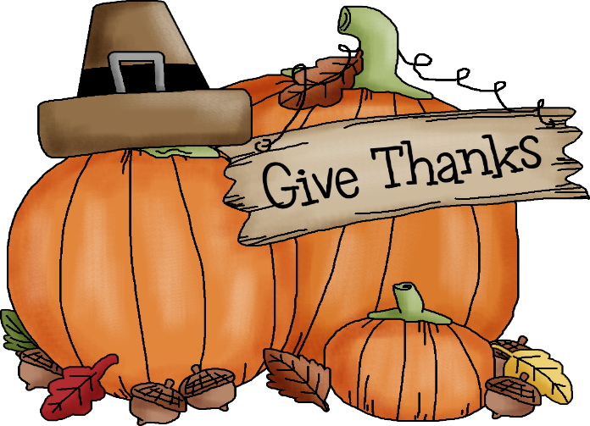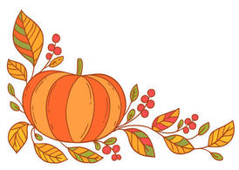

2018

**United Presbyterian Church Youth Group**

**Thanksgiving Pie Sale**

Name: _______________________

Phone Number:_________________

***Orders are Due by November 11th***

***Pies can be Picked Up at UPC***

***Wednesday, November 21st at 5pm***

Wednesday, November 23th at 6pm

Small Cheesecake $12

|  |  |  |  |  |
| --- | --- | --- | --- | --- |
| _______  _______  _______  _______  _______  _______  _______ |  | Pumpkin  Almond Amaretto  Blueberry Swirl  Black Forrest  Cherry  Strawberry Swirl  Variety (Plain, Chocolate Swirl, Raspberry, Strawberry Swirl) | | |
|  | | |  |  |

Apple

8 Inch No Sugar Added Pies $12

|  |  |  |
| --- | --- | --- |
| _______  _______  _______  _______ | Apple  Blueberry  Cherry  Peach | |
|  | |  |

Apple

Cakes $18

|  |  |  |
| --- | --- | --- |
| _______  _______  _______  _______ | Coconut  Carrot  Triple Chocolate  Pumpkin with Cream Cheese Icing | |
|  | |  |

Apple

10 Inch Pies $16

|  |  |  |
| --- | --- | --- |
| _______  _______  _______  _______  _______  _______  _______  _______  _______  _______  _______  _______  _______  _______  _______  _______ | Apple  Apple Caramel Walnut  Apple Cranberry  Pumpkin  Sweet Potato  Pecan  Cherry  Blueberry  Mixed Fruit  Peachberry  Apple Crumb  Cherry Crumb  Pineapple Upsidedown  Peanut Butter Cream  Banana Cream  Chocolate Mousse | |
| _______  _______  _______  _______  _______  _______  _______  _______  _______  _______  _______  _______  _______ | | Apple  Apple Caramel Walnut  Apple Cinnamon  Pumpkin  Sweet Potato  Pecan  Cherry  Blueberry  Mixed Fruit  Apple Crumb  Key Lime  Pumpkin Cream  Peanut Butter Cream |

Apple