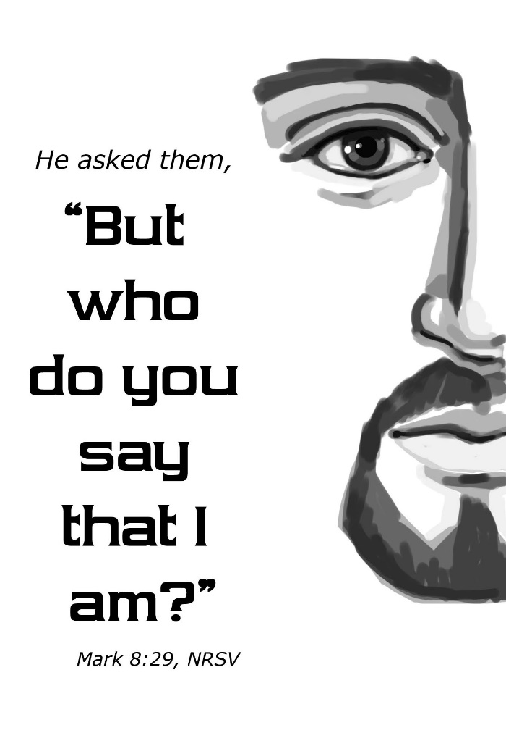
UNITED PRESBYTERIAN CHURCH

NOVEMBER 11th, 2018

12 Yardville-Hamilton Square Rd
Yardville, NJ 08620
(609) 585 – 5770
www.upcnj.org office.upcnj@gmail.com

WELCOME
You have come to hear the Word of God, and you shall hear it read and preached. We hope that by hearing it, you will also meet the Word of God, the Living Word, Jesus, Our Savior. And we pray that you will leave our church equipped to serve him more faithfully and effectively.

SERVICE FOR THE LORD’S DAY
November 11th, 2018

PRELUDE “Savior of the Nations Come” A. N. Vetter
ANNOUNCEMENTS
PRAYER HYMN “Here I am to Worship” Hillsong Worship
Here I am to Worship
Here I am to bow down
Here I am to say that you’re my God
You’re altogether worthy
Altogether lovely
Altogether wonderful to me (repeat)

WE COME TO WORSHIP GOD
CALL TO WORSHIP
Leader: We gather to worship God, whose words and ways challenge us.
People: God invites us to lose our selfishness in order to find ourselves.
Leader: God urges us to empty ourselves in order to discover life’s fullness.
People: God bids us to be obedient to the divine will so that we might know true freedom.
Leader: We come to worship our Creator.
People: We come to that our identity in Christ may be more fully realized.
*HYMN “Hear the Good News of Salvation” #355
CALL TO CONFESSION
If we say we have no sin, we deceive ourselves, and the truth is not in us. But if we confess our sin God, who is faithful and just, will forgive us our sins. In humility and faith, let us confess our sin to God.

PRAYER OF CONFESSION
God, we have filled our lives with so many things that there is scarcely room left for each other and for You. “There’s no time!” we protest. “I know you’re busy,” we assume. “Get ahead!” we urge ourselves and our children, as our lives become a dizzy flurry of distraction, deadline, and duty. Slow us down, God: Forgive our busy-ness, which destroys our openness, our preoccupation, which leaves us unaware of the gentle breeze of Your Spirit, our self-absorption, which makes us ignore the crises of those in need. And if we have not yet been possessed by Your grace and acceptance, we pray that we may be open to it now. In the name of Jesus Christ, we pray. Amen.

SILENT PRAYER
ASSURANCE OF PARDON
*GIVE GOLRY TO GOD “Give Glory to the Father” #577
Glory be to the Father, and the Son, and the Holy Ghost;
As it was in the beginning, is now and ever shall be,
World without end. Amen.
As it was in the beginning, is now and ever shall be,
World without end. Amen.
Amen. Amen. Amen. Amen.
Amen. Amen. Amen.
PRAYER FOR ILLUMINATION
Living God, help us so to hear your holy Word that we may truly understand; that, understanding, we may believe, and, believing, we may follow in all faithfulness and obedience, through Christ our Lord. Amen.
OLD TESTAMENT LESSON: GENESIS 17:1-7, 15-16
¹When Abram was ninety-nine years old, the Lord appeared to Abram, and said to him, ‘I am God Almighty; walk before me, and be blameless. ²And I will make my covenant between me and you, and will make you exceedingly numerous.’ ³Then Abram fell on his face; and God said to him, ⁴As
for me, this is my covenant with you: You shall be the ancestor of a multitude of nations. ⁵No longer shall your name be Abram, but your name shall be Abraham; for I have made you the ancestor of a multitude of nations. ⁶I will make you exceedingly fruitful; and I will make nations of you, and kings shall come from you. ⁷I will establish my covenant between me and you, and your offspring after you throughout their generations, for an everlasting covenant, to be God to you and to your offspring after you.¹⁵God said to Abraham, ‘As for Sarai your wife, you shall not call her Sarai, but Sarah shall be her name. ¹⁶I will bless her, and moreover I will give you a son by her. I will bless her, and she shall give rise to nations; kings of peoples shall come from her.’

ANTHEM “You Are My All in All” L. Larson
NEW TESTAMENT LESSON: MARK 8:27-35
²⁷Jesus went on with his disciples to the villages of Caesarea Philippi; and on the way he asked his disciples, ‘Who do people say that I am?’²⁸And they answered him, ‘John the Baptist; and others, Elijah; and still others, one of the prophets.’ ²⁹He asked them, ‘But who do you say that I am?’ Peter answered him, ‘You are the Messiah.’ ³⁰And he sternly ordered them not to tell anyone about him.³¹Then he began to teach them that the Son of Man must undergo great suffering, and be rejected by the elders, the chief priests, and the scribes, and be killed, and after three days rise again. ³²He said all this quite openly. And Peter took him aside and began to rebuke him. ³³But turning and looking at his disciples, he rebuked Peter and said, ‘Get behind me, Satan! For you are setting your mind not on divine things but on human things.’³⁴ He called the crowd with his disciples, and said to them, ‘If any want to become my followers, let them deny themselves and take up their cross and follow me. ³⁵For those who want to save their life will lose it, and those who lose their life for my sake, and for the sake of the gospel, will save it.

SERMON
“Is That Your Final Answer?” Rev. Byron Shafer
MOMENT FOR QUIET REFLECTION

*HYMN “Take Thou Our Minds, Dear Lord” #392
(Joys and concerns may be written on the pew cards and given to the ushers during this hymn. They will be shared during the prayers of the people, unless you mark them confidential.)
WE RESPOND TO GOD’S WORD
*AFFIRMATION OF FAITH – The Apostle’s Creed
I believe in God the Father Almighty, Maker of heaven and Earth. And in Jesus Christ his only Son our Lord; who was conceived by the Holy Ghost, born of the Virgin Mary, suffered under Pontius Pilate, was crucified dead, and buried; he descended into hell; the third day he rose again from the dead; he ascended into heaven, and sitteth on the right hand of God the Father Almighty; from thence he shall come to judge the quick and the dead. I believe in the Holy Ghost; the holy Catholic Church; the communion of saints; the forgiveness of sins; the resurrection of the body; and the life everlasting. Amen.

PRAYERS OF THE PEOPLE AND THE LORD’S PRAYER
CONGREGATIONAL RESPONSE
Hear our prayer, O Lord, Hear our prayer, O Lord
Incline Thine ear to us, and grant us thy peace.
WE PRESENT TO GOD OUR GIFTS AND OFFERINGS
OFFERTORY “Arise, Give Glory to God” M. G. Fischer

*WE GIVE PRAISE AND THANKS TO GOD
Praise God from whom all blessings flow; Praise Him all creatures here below;
Alleluia, Alleluia.
Praise him above ye heavenly host; Praise Father Son and Holy Ghost.
Alleluia! Alleluia! Alleluia! Alleluia! Alleluia!
*PRAYER TO DEDICATE OUR GIFTS
Leader: O God, we affirm our live for other by our presentation of these gifts and by our vows of renewed commitment
People: Receive these offerings as sincere affirmations of our love for You.
All: Amen.
*HYMN “The Church of Christ in Every Age” #421
WE RECEIVE GOD’S BLESSING
POSTLUDE: “Fantasia” J. Pachelbel
*THOSE WHO ARE ABLE MAY STAND

TODAYS FLOWERS Tony & Camille Nami
GREETERS & USHERS Donna Bade & Dot Schroeder

UPCOMING EVENTS
October 28st – November 4th
Sun 11/11 | Mon 11/12 | Tue 11/13 | Wed 11/14 | Thur 11/15 | Fri 11/16 | Sat 11/17 | Sun 11/18
9:30am-Adult Sunday School  9:30am-E3 Worship  11am-Worship Service  6pm-Youth Group | 12pm- A/A  8pm- N/A | 12pm- A/A | 10:30am-Survivors Meeting  6pm-Boy Sct Den #1  7pm-Session | 6:30pm- Girl Scout Trp#70015  7:30pm – Choir  8pm- A/A | 4pm- Girl Scoutt Trp #71854  8pm- A/A | 9am – UPC Men’s Grp | 9:30am- Adult Sunday School  9:30am-E3 Worship  10:15am-Coffe Hour  11am-Communion Service

PRAYER REQUESTS
Chris S. – Not well John Borek – Cancer Dr. John Bock-Cancer
Cindy – Family health issues Dr. Jeff Cook – Cancer Marilyn & Frank Kostar
Pam & Dan Bud – Cancer
Charlie Jenna Giambelluca – Cancer
Carol & Al D’Amico Healing of depression of friends & family
Connie Elcolino Maureen Gillespie – Lung cancer & on chemo
Susan – Healing Margaret Dunicliff – comfot of bereaved family
Gail Hall - Knee Art
Ruth – Healing Donna
Carolyn - healing Dinah
Tom & Sue – Healing John
Fred Kenzie

CHRISTMAS CANTATA CHOIR: The cantata will be presented on December 16, 2018 (Third Sunday of Advent) during the 11 a.m. worship service. There will be a dress rehearsal on Sat., Dec. 8th at 10 a.m. in the sanctuary. Weekly rehearsals are on Thursday at 7:30 p.m.

THE SURVIVORS SENIOR GROUP The Survivors will meet at the church in the Fellowship Hall, on November 14th at 10:30 a.m. for a presentation by Kathleen Kelly Hamilton. She will speak about New Jersey Estate Planning. Following her presentation we will enjoy lunch at Hamilton Tap & Grill at The Shoppes at Hamilton. If you plan to attend please make your reservation with Rita Peterson (609) 259-7256 or email ritapete@optonline.net .All seniors of the church and their friends are welcome to join. The Survivors community project this year is to collect sweatshirts with hoods, hats, gloves and scarves for the Trenton Area Soup Kitchen (TASK). There is a box in the back of the sanctuary where you can drop off your donations. The deadline for your donations is December 2nd.

WOMENS BOOK CLUB will meet on Tuesday evening, Nov. 27th at 7pm in the Bertolett Lounge. We will be discussing Clara and Mr. Tiffany by Susan Vreeland. All women of the church and their friends who enjoy good books, good fellowship, and yummy deserts are encouraged to join us. December: A Dog Named Christmas by Greg Kincaid

MEN’S GROUP will meet on the 3rd Saturday of the month at 9:00am at the Golden Dawn Diner on Whitehorse-Mercerville Rd. Any questions should be asked to Jim Dixon at 609-298-3398 (home) or 609-577-4849 (cell).

CHRISTMAS GIFT CARD CAMPAIGN BEGINNING NOVEMBER 11 with a last order date of December 9. Order forms are available in the Narthex. Please attach your check to the order form and place it in the offering plate or in the Financial Secretary mail box in the church office.

OUR MISSION STATEMENT
We are called by Jesus Christ and empowered by the Holy Spirit to celebrate
And share the love of God with grace and joy. Gracefully and joyfully we seek to share our gifts in the community through: Open Doors, Diverse Worship, Innovative Education, Creative Mission, and Dynamic Service.
INVITATION TO CHRISTIAN DISCIPLESHIP
You are invited to make a commitment to follow Jesus Christ as Lord of Life, or to renew your commitment as a Christian Disciple. Please speak to the pastor who will talk and pray with you. If you are looking for a church home we invite you to join this family of faith and service. This is a caring congregation, open to all. Please let us know we can serve you.
CHURCH STAFF
Ministers: All Members of the Congregation
Pastors Emeriti: Rev. Terry E. Fouse, Rev. John H. Milne
Organist/Choir Director: Marilyn Machmer
Church Secretary: Katlin Briggs
PRAYER REQUESTS
Prayer Requests Daytime: Church office Tel. (609) 585-5770
Evening: Joyce Vaughn Tel. (609) 915-3733
If you would like to make a written contribution to our worship bulletin, please forward same to the church office no later than Monday @ 12 noon. Thank you.

