UNITED PRESBYTERIAN CHURCH

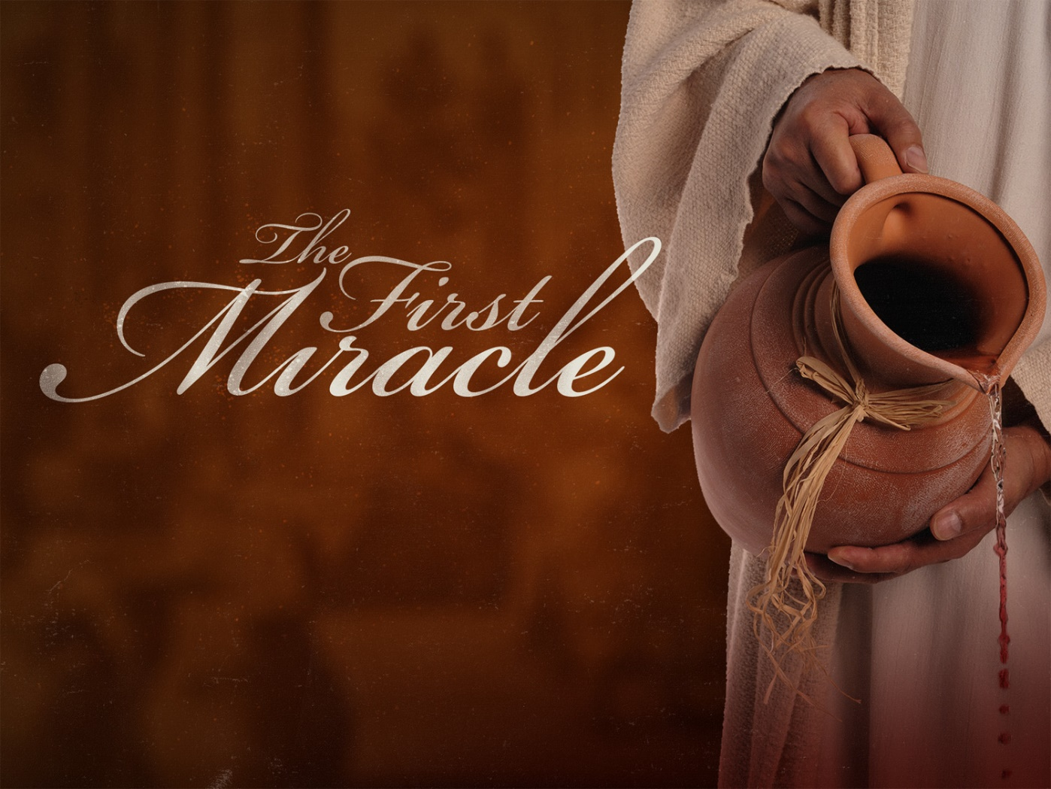

JANUARY 20TH, 2019

12 Yardville-Hamilton Square Rd
Yardville, NJ 08620
(609) 585 – 5770
www.upcnj.org office.upcnj@gmail.com
WELCOME
You have come to hear the Word of God, and you shall hear it read and preached. We hope that by hearing it, you will also meet the Word of God, the Living Word, Jesus, Our Savior. And we pray that you will leave our church equipped to serve him more faithfully and effectively.

SERVICE FOR THE LORD’S DAY
January 20th, 2019

PRELUDE “How Great Thou Art” arr. J. Carter

ANNOUNCEMENTS

PRAYER HYMN “Dear Lord and Father of Man Kind” #345
Dear Lord and Father of mankind, forgive our foolish ways,
Re-clothe us in our rightful mind
In purer lives Thy service find
In deeper reverence, praise

WE COME TO WORSHIP GOD
CALL TO WORSHIP
Leader: We come this day, Precious God, as people in need of your steadfast love.
All: With you is the fountain of life; in your Light we see light.
Leader: We gather this day, Water-changing God, as people looking for signs.
All: With you is the fountain of life; in your Light we see light.
Leader: We worship this day, Gifting God, as people who confess Jesus as our Lord,
All: With you is the fountain of life; in your Light we see light.

*HYMN “All Hail the Power of Jesus’ Name!” #142

CALL TO CONFESSION

PRAYER OF CONFESSION
Delight of the Ages, we cannot remain silent, but must speak of the ways we misuse your gifts. In our desire to have more and more, we cause more damage to your good creation. In our obsession with ourselves, we have desolated the lives of those around us. When we hoard what you have given us, we cannot be a blessing to other people.

SILENT PRAYER

ASSURANCE OF PARDON
One: God delights in you. So much, that God will not rest until you are at peace. God will not remain silent, but will call you by name: ‘My Delight.’
All: God’s steadfast love extends to the heavens and reaches down to touch our hearts. Thanks be to God who forgives and saves.
*GIVE GLORY TO GOD “Give Glory to the Father” #577
Glory be to the Father, and the Son, and the Holy Ghost;
As it was in the beginning, is now and ever shall be,
World without end. Amen.
As it was in the beginning, is now and ever shall be,
World without end. Amen.
Amen. Amen. Amen. Amen.
Amen. Amen. Amen.
PRAYER FOR ILLUMINATION
Gracious God, give us humble and teachable hearts, that we may receive what you have revealed, and do what you want us to.

OLD TESTAMENT LESSON: ISAIAH 62:1-5
¹For Zion’s sake I will not keep silent, and for Jerusalem’s sake I will not rest. Until her vindication shines out like the dawn, and her salvation like a burning torch. ²The nations shall see your vindication, and all the kings your glory; and you shall be called by a new name that the mouth of the Lord will give. ³You shall be a crown of beauty in the hand of the Lord, and a royal diadem in the hand of your God. ⁴You shall no more be termed forsaken, and your land shall no more be termed desolate, but you shall be called My Delight Is in Her, and your land married for the Lord delights in you, and your land shall be married. ⁵For as a young man marries a young woman, so shall your builder marry you, and as the bridegroom rejoices over the bride, so shall your God rejoice over you.

ANTHEM “Stories of Jesus” arr. Page / Shafferman

NEW TESTAMENT LESSON: JOHN 2:1-11
¹On the third day there was a wedding in Cana of Galilee, and the mother of Jesus was there. ²Jesus and his disciples had also been invited to the wedding. ³When the wine gave out, the mother of Jesus said to him, ‘They have no wine.’ ⁴And Jesus said to her, ‘Woman, what concern is that to you and me? My hour has not yet come.’ ⁵His mother said to the servants, ‘Do whatever he tells you.’ ⁶Now standing there were six stone water-jars for the Jewish rites of purification, each holding twenty or thirty gallons. ⁷Jesus said to them, ‘Fill the jars with water’. And they filled them up to the brim. ⁸He said to them, ‘Now draw some out, and take it to the chief steward.’ So they took it. ⁹When the steward tasted the water that had become wine, and did not know where it came from (though the servants who had drawn the water knew), the steward call the bridegroom ¹⁰and said to him, ‘Everyone serves the good wine first, and then the inferior wine after the guests have become drunk. But you have kept the good wine until now.’ ¹¹Jesus did this, the first of his signs, in Cana of Galilee, and revealed his glory; and his disciples believed in him.

SERMON
“A Symbolic Extravagance” Rev. Alice Batcher

MOMENT FOR QUIET REFLECTION
*HYMN “For the Beauty of the Earth” #473
(Joys and concerns may be written on the pew cards and given to the ushers during this hymn. They will be shared during the prayers of the people, unless you mark them confidential.)

WE RESPOND TO GOD’S WORD
*AFFIRMATION OF FAITH – The Apostle’s Creed
I believe in God the Father Almighty, Maker of heaven and Earth. And in Jesus Christ his only Son our Lord; who was conceived by the Holy Ghost, born of the Virgin Mary, suffered under Pontius Pilate, was crucified dead, and buried; he descended into hell; the third day he rose again from the dead; he ascended into heaven, and sitteth on the right hand of God the Father Almighty; from thence he shall come to judge the quick and the dead. I believe in the Holy Ghost; the holy Catholic Church; the communion of saints; the forgiveness of sins; the resurrection of the body; and the life everlasting. Amen.
PRAYERS OF THE PEOPLE & THE LORD’S PRAYER

CONGREGATIONAL RESPONSE
Hear our prayer, O Lord. Hear our prayer, O Lord.
Incline Thine ear to us, and grant us Thy Peace.

WE PRESENT TO GOD OUR GIFTS AND OFFERINGS
OFFERTORY “Offertoire” C.Franck
*WE GIVE PRAISE AND THANKS TO GOD
Praise God from whom all blessings flow; Praise Him all creatures here below;
Alleluia, Alleluia.
Praise him above ye heavenly host; Praise Father Son and Holy Ghost.
Alleluia! Alleluia! Alleluia! Alleluia! Alleluia!

*PRAYER TO DEDICATE OUR GIFTS
Holy God who gives and then gives more: it’s the offering time again. We pass the plate and place a gift of money to sustain the mission of your church, here and around the world. We are reminded that we have other gifts as well, not noted on our bank statements or balance sheets. You have given each of us spiritual gifts, not to make us rich but to make the world richer, more compassionate and more just, because we were here. Open our eyes to those gifts, and where and when you would have us use them. In the Savior’s name, we pray. Amen.

*HYMN “Immortal, Invisible, God Only Wise” #263

WE RECEIVE GOD’S BLESSING

POSTLUDE: “All Hail the Power of Jesus’ Name” arr. H. Hopson
TODAYS FLOWERS Verna & Vern Halmes – In Memory of Loved Ones
GREETERS & USHERS Heidi Vandergrift & Joan Reid

UPCOMING EVENTS
January 13th – January 20th
Sun 1/20 | Mon 1/21 | Tue 1/22 | Wed 1/23 | Thur 1/24 | Fri 1/25 | Sat 1/26 | Sun 1/27
9:30am-Adult Sunday School  9:30am-E3 Worship  11am-Worship Service  12pm – Annual Congregational Meeting  6pm – Youth Group | 12pm- A/A  7pm- Boy Sct Trp 91  8pm- N/A | 12pm- A/A  7pm –Women’s Book Club | 6pm- Boy Sct Den #1 | 6pm – Boy Sct Den#7  7:30- Choir  8pm- A/A | 4pm- Boy Sct Den  #5  8pm- A/A | 7pm- A/A | 9:30am- Adult Sunday School  9:30am-E3 Worship  11am-Worship Service

PRAYER REQUESTS
Tom & Sue Jim
Pam & Dan Rose Donna
Susan Anthony Doris
Rhea Mucha Sylvia
Jeff Cook – Cancer Marge - Dementia
Pat – Traveling mercies
John Borek – Cancer
Dr. John Bock – Cancer
Judy D’Amico
The Del Family
Ginny Perry – Bronchitis & recovering from broken femur
Comfort for friends & family of Gail Roberts who passed

WOMENS BOOK CLUB will meet on Tuesday evening, Jan 22nd at 7pm in the Bertolet Lounge. We will be discussing Close to Shore by Michael Capuzzo. All women of the church and their friends who enjoy good books, good fellowship, and yummy deserts are encouraged to join us. February: Rebecca by Daphne du Mauier.

CONGREGATIONAL MEETING The Session of United Presbyterian Church has called a Congregational Meeting for January 20th following the 11:00am Worship Service. The meeting is being called to elect Deacons, Elders and members of the 2019 nominating committee as well as to receive the 2018 Annual Reports and conduct any other business that arises.

SUPER BOWL SUNDAY FEB 3rd UPC will be collecting canned goods and money for the Food Pantry at Christ Presbyterian Church.

THE SURVIVORS SENIOR GROUP will meet at church, Fellowship Hall, on Wed., Feb. 13th at 12:00 p.m. to play Bunco. We ask that you bring a bag lunch and dessert or salad to share. Drinks will be provided. All seniors and their friends are welcome to participate in our annual Bunco afternoon. Please contact Rita Peterson at 609-259-7256 or email
ritapete@optonline.net if you plan to attend. I would like to thank everyone that has saved tabs for the Ronald McDonald House this past year and ask for your continued support of this wonderful organization.

OUR MISSION STATEMENT
We are called by Jesus Christ and empowered by the Holy Spirit to celebrate
And share the love of God with grace and joy. Gracefully and joyfully we seek to share our gifts in the community through: Open Doors, Diverse Worship, Innovative Education, Creative Mission, and Dynamic Service.

INVITATION TO CHRISTIAN DISCIPLESHIP
You are invited to make a commitment to follow Jesus Christ as Lord of Life, or to renew your commitment as a Christian Disciple. Please speak to the pastor who will talk and pray with you. If you are looking for a church home we invite you to join this family of faith and service. This is a caring congregation, open to all. Please let us know we can serve you.

CHURCH STAFF
Ministers: All Members of the Congregation
Pastors Emeriti: Rev. Terry E. Fouse, Rev. John H. Milne
Organist/Choir Director: Marilyn Machmer
Church Secretary: Katlin Briggs
PRAYER REQUESTS
Prayer Requests Daytime: Church office Tel. (609) 585-5770
Evening: Joyce Vaughn Tel. (609) 915-3733
If you would like to make a written contribution to our worship bulletin, please forward same to the church office no later than Monday @ 12 noon. Thank you.

